COMMISSIONERATE OF COLLEGIATE EDUCATION GOVERNMENT OF ANDHRA PRADESH

GOVT DEGREE COLLEGE (W), MADANAPALLE
ANNAMAYYA DIST
NEWS LETTER FOR THE MONTH OF MARCH-2025

Vision & Mission:
Vision: To impart higher education to all segments of society with special emphasis on the students of socially & economically backward sections of the society. To impart value-based education. To increase literacy level among the women by providing educational facility leading to women empowerment, To enhance the spirit of Nationality, National Integrity and inculcate high moral values. To provide guidance for competitive exams and ensure all-round personality development. To develop social concern and civic responsibilities among the upcoming talented youth.
Mission: To produce knowledgeable, responsible skilled, cultured, confident and competent← future citizens of India with a desire to its progress and welfare. The students coming out of the portals of this institution shall have the abilities to know, learning to do, learning to live and learning to be responsible citizens.

Principal’s Message:
I am extremely happy that Government Degree College for Women, Madanapalle has been in the practice of various curricular, co-curricular and extra -curricular activities for the welfare of all women students. Several innovative programs and Best Practices are unique to our institution, which intends of offering value based and quality education to the students under the guidance of APCCE, APSCHE and S.V. University. In realization of the aim of our institution, the students are helped to grow into fine human beings who are capable to face the challenges of the present world. All the developmental activities would not have been possible without the support and co-operation of the students and the teachers. I wish the college would continue to grow in all ways in the days to come. This newsletter echoes the highlights of the college activities.

CONTENTS
S.NO | Date | Name of the activity | Page No
1 | 01.03.2025 | Awareness program On Help desk at II- Town Police Station by NSS | 4-4
2 | 03.03.2025 | Essay writing competition by Dept. of Police on the eve of International Women's Day | 5-5
3 | 04.03.2025 | Awareness Program on "Need of digital safety for women" by Dept. of Police | 6-6
4 | 07.03.2025 | Survey on women preferences by Eenadu news paper | 7-7
5 | 08.03.2025 | Celebration of International Women's Day by Women Empowerment Cell | 8-10
6 | 10.03.2025 | ABVP organized the volleyball and kabbadi tournament our students got volleyball winner and additional runners | 11-13
7 | 11.03.2025 | Academic Audit 2023-2024 &2024-2025 | 14-17
8 | 13.03.2025 | Poster Making Competition On The Dangers Of Plastic Usage | 18-20
9 | 15.03.2025 | Essay writing competition organised by Department of Commerce as a part of World Consumer Rights Day celebrations | 21-21
10 | 21.03.2025 | National youth Parliament competition at KSRM Engineering College, Kadapa. | 22-22
11 | 21.03.2025 | World Poetry Day | 23-24
12 | 22.03.2025 | NFLP( Training Program) | 25-25
13 | 25.03.2025 | Distribution of Butter Milk by NSS. | 26-27
14 | 29.03.2025 | Campus job drive | 28-29

Awareness program On Help desk at II- Town Police Station by NSS
The NSS unit visited the II-Town Police Station Madanapalle on 1/3/2025 for awareness on the help desk arranged at the police station. The program officer, Dr.B.Jyothi went to the help desk along with the students.

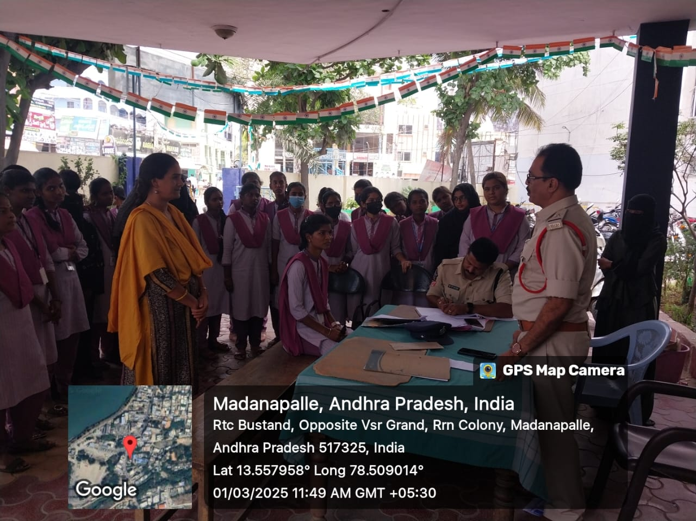
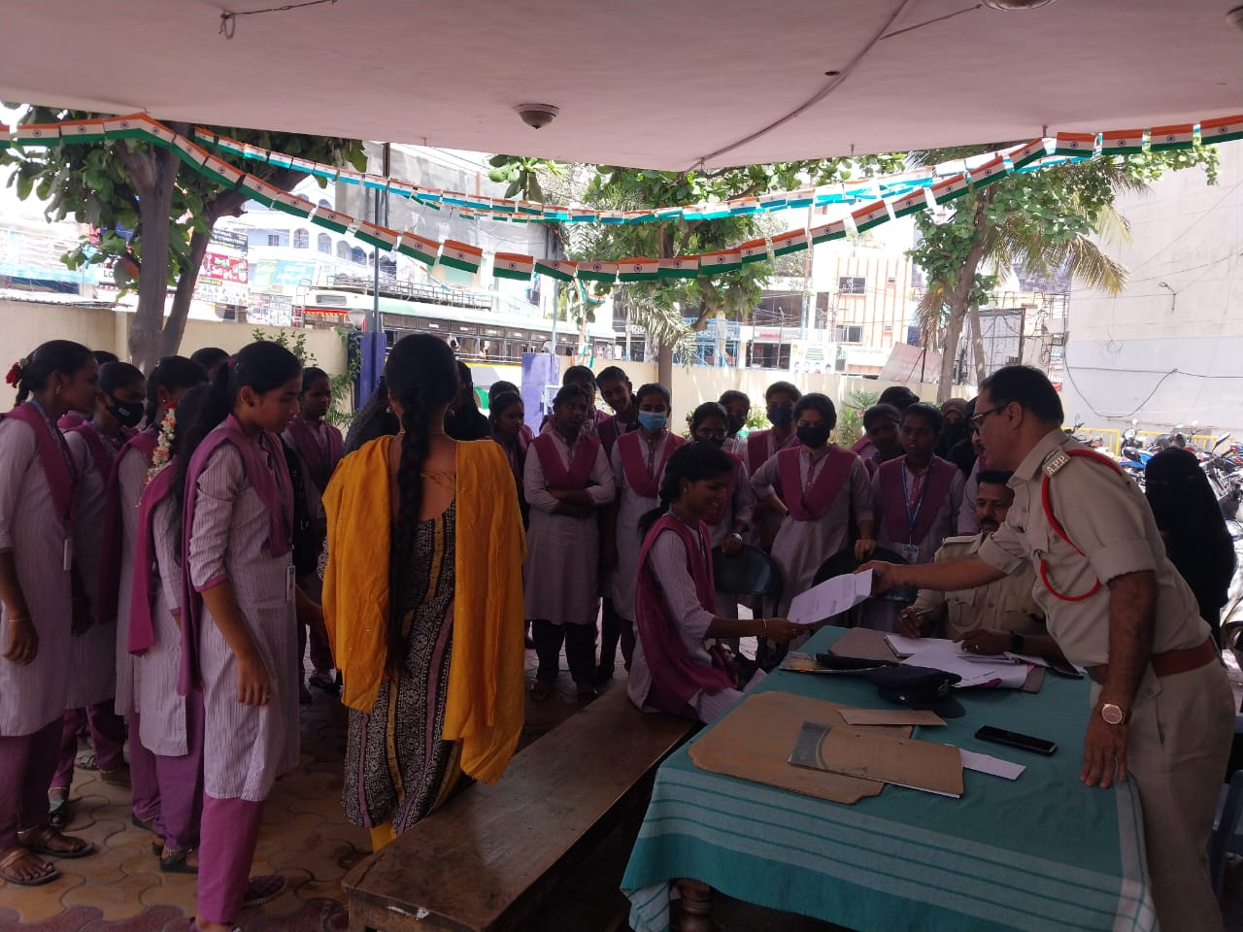
Essay writing competition by Dept. of Police on the eve of International Women's Day
The department of police conducted essay writing competition on 3/3/2025 in collaboration with Women Empowerment Cell of the college on the eve of International Women's Day.

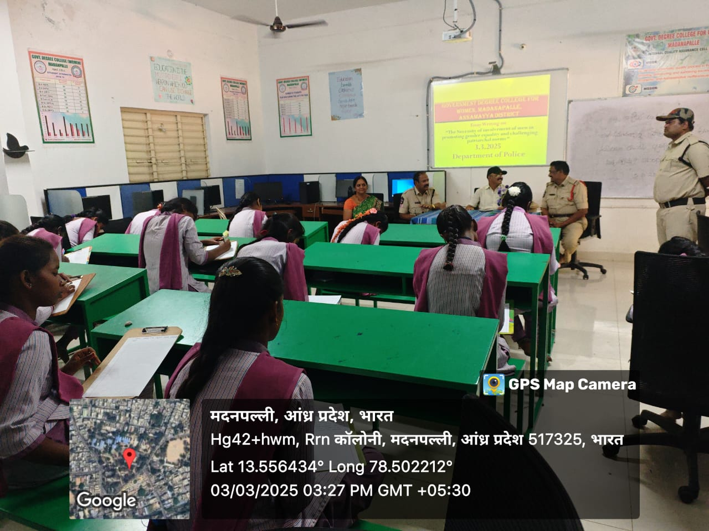
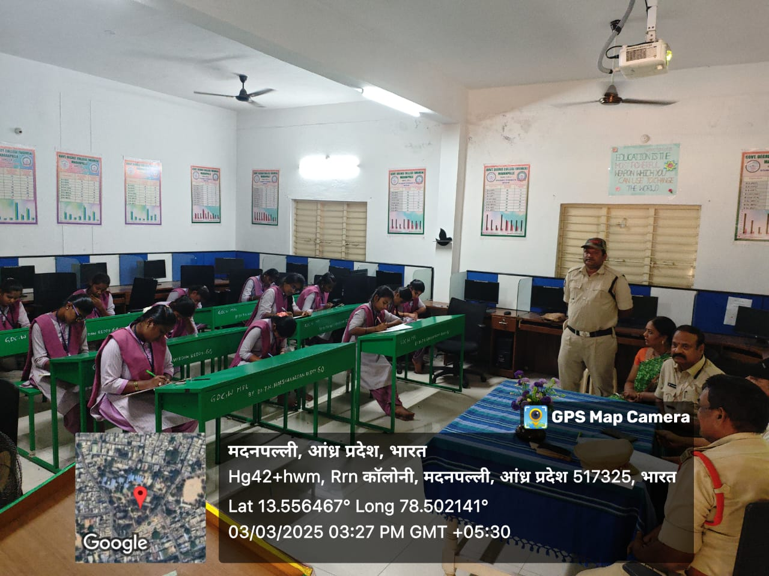

Awareness Program on "Need of digital safety for women" by Dept. of Police
On 4/3/2025 an awareness program was conducted by the Department of Police on "Need of digital safety for women". The principal Dr. R. KrishnaVeni and the police personnel addressed the students. Later the prizes were distributed to the winners in the essay writing competitions.
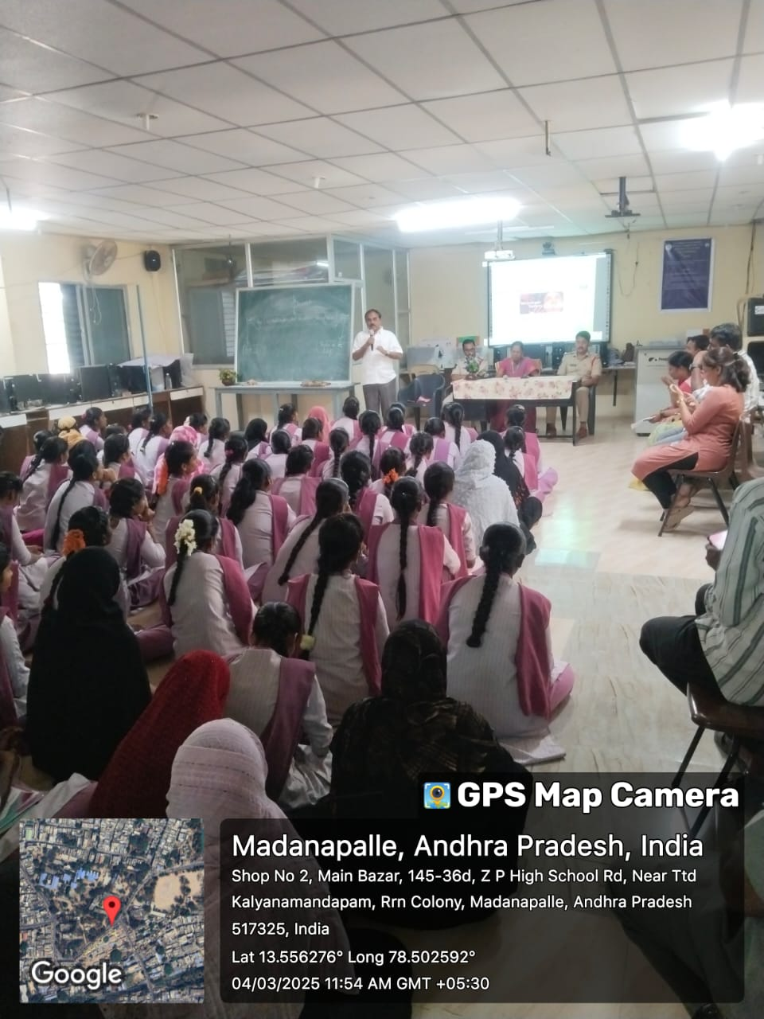
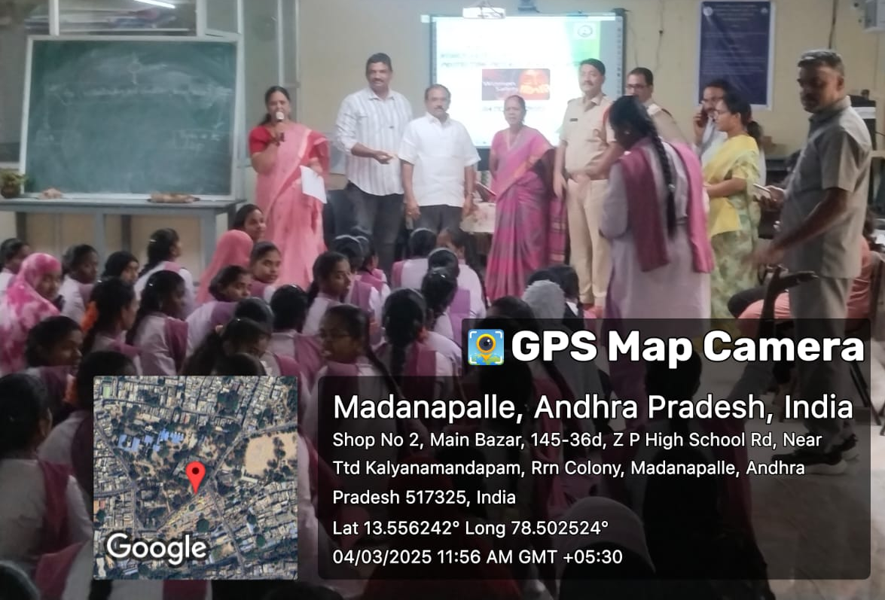

Survey on women preferences by Eenadu news paper
On the eve of International Women’s Day a survey on the women preferences was conducted in the college by the EENADU news paper personnel.

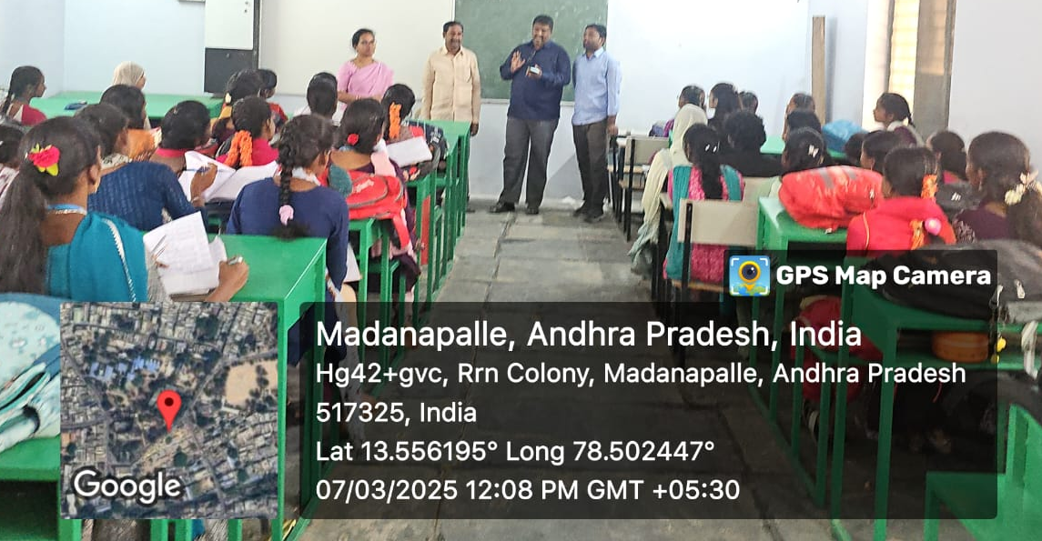

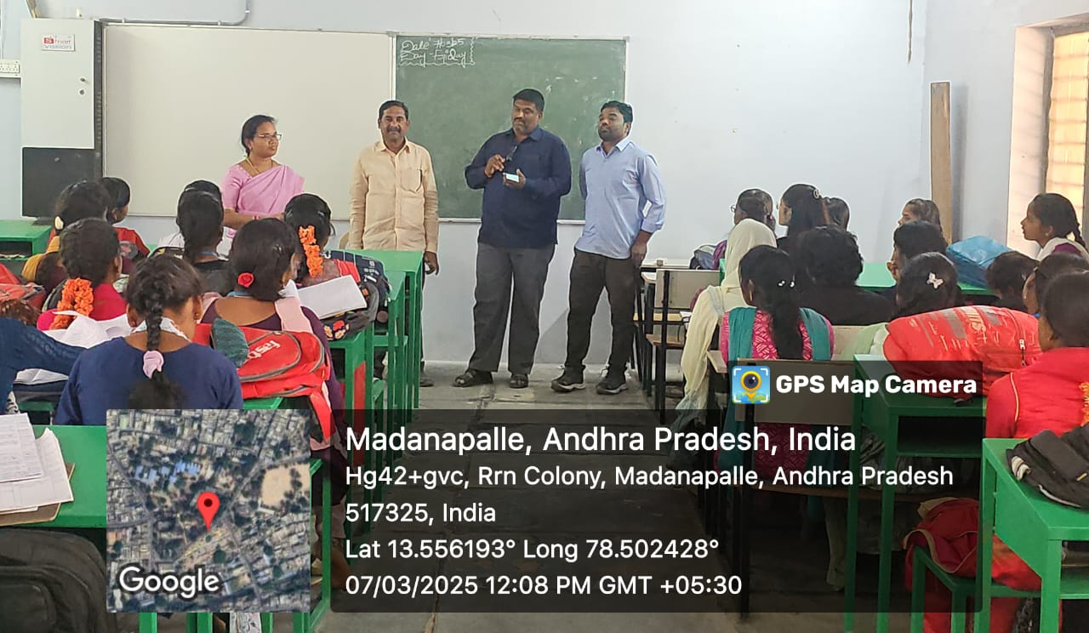

Celebration of International Women's Day
International women’s Day was celebrated in the premises of the college. The principal Dr.R.Krishnaveni District Second Additional judge ABRAHAM, The founder of Dhathri Foundation , Smt Swathi , women advocates, the faculty and the students participated in it.

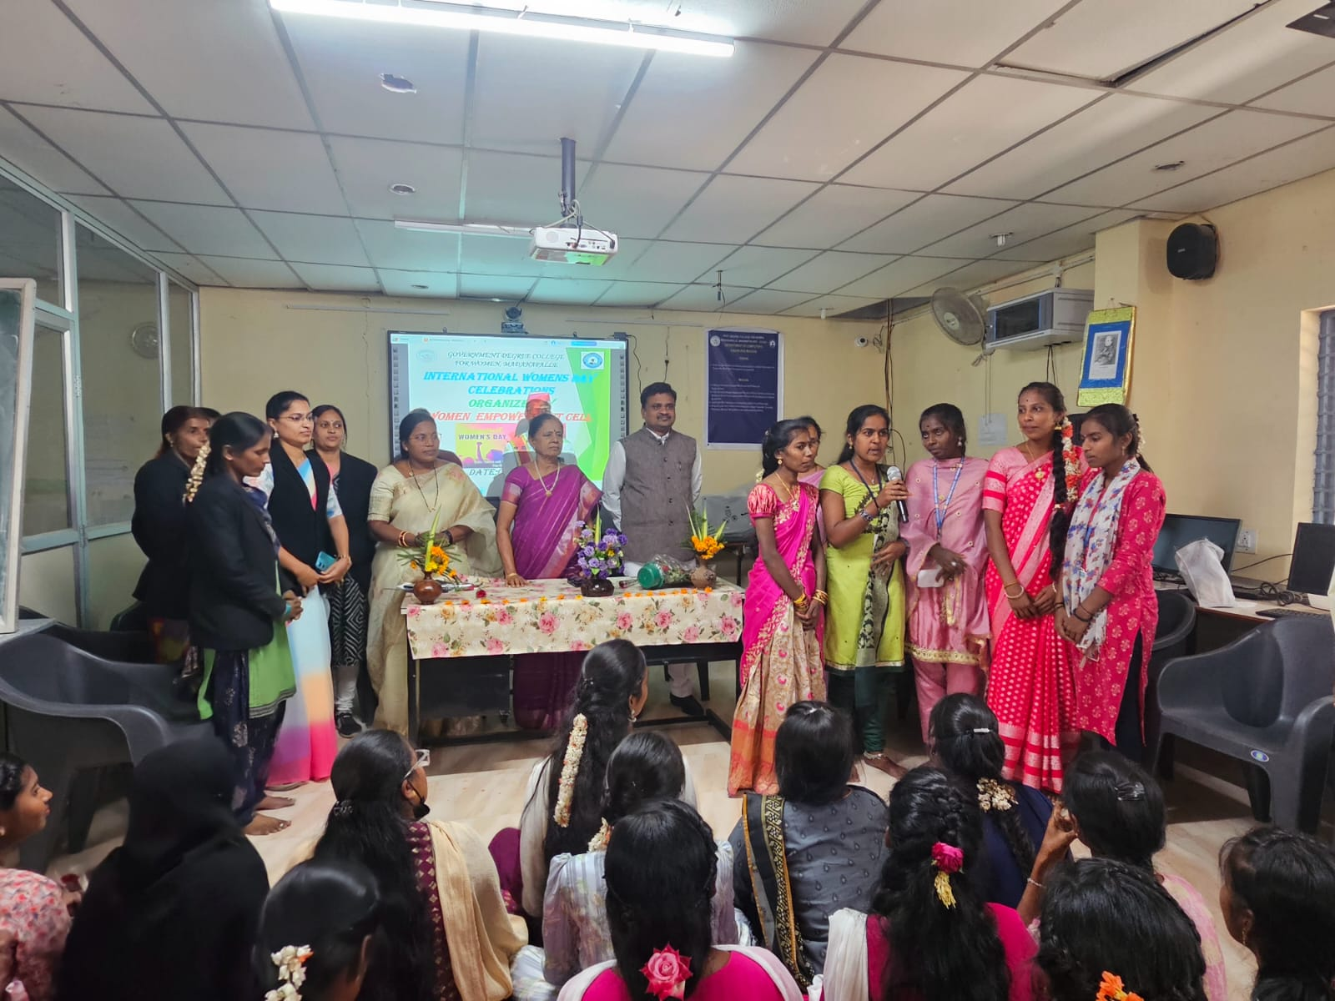
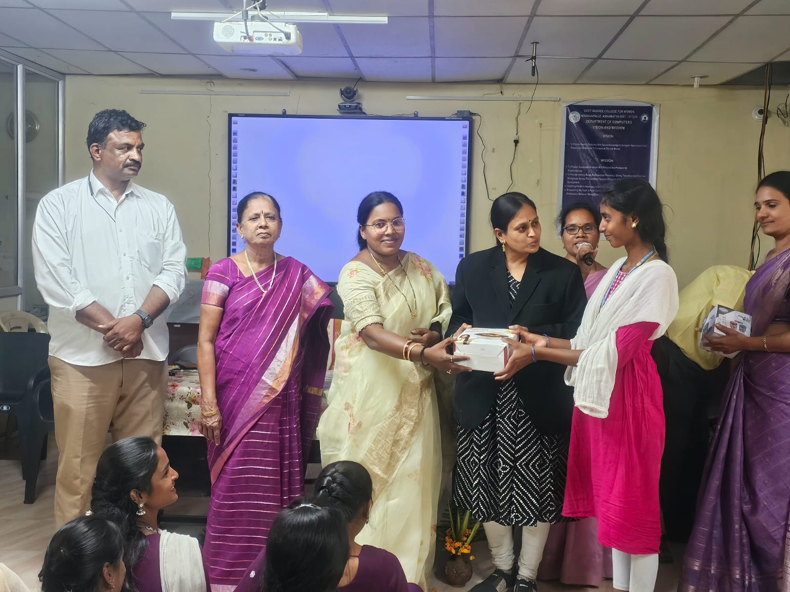

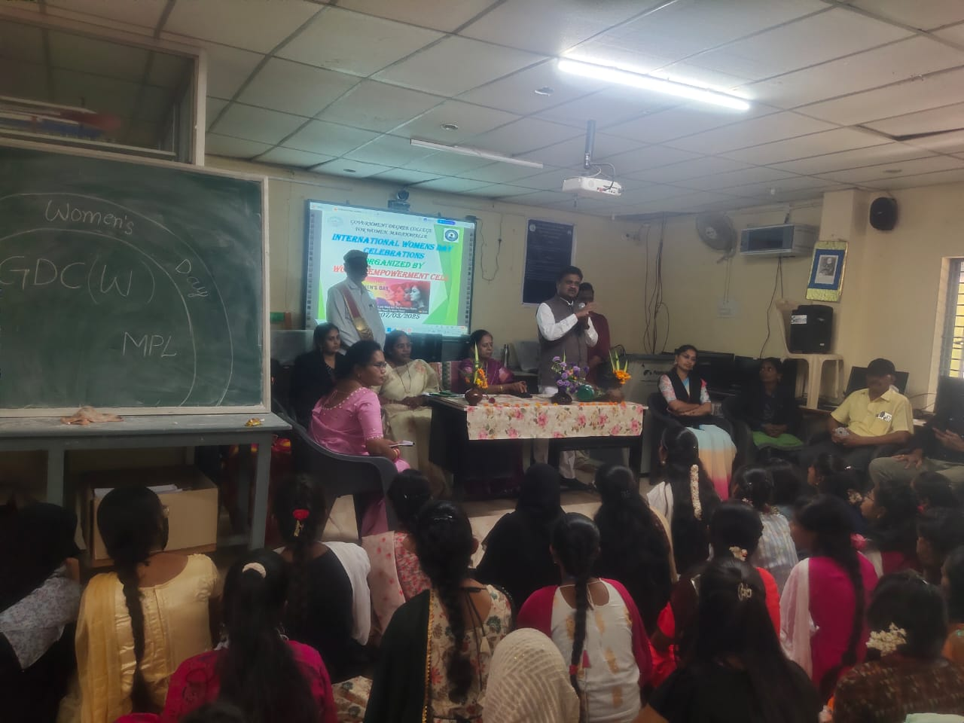
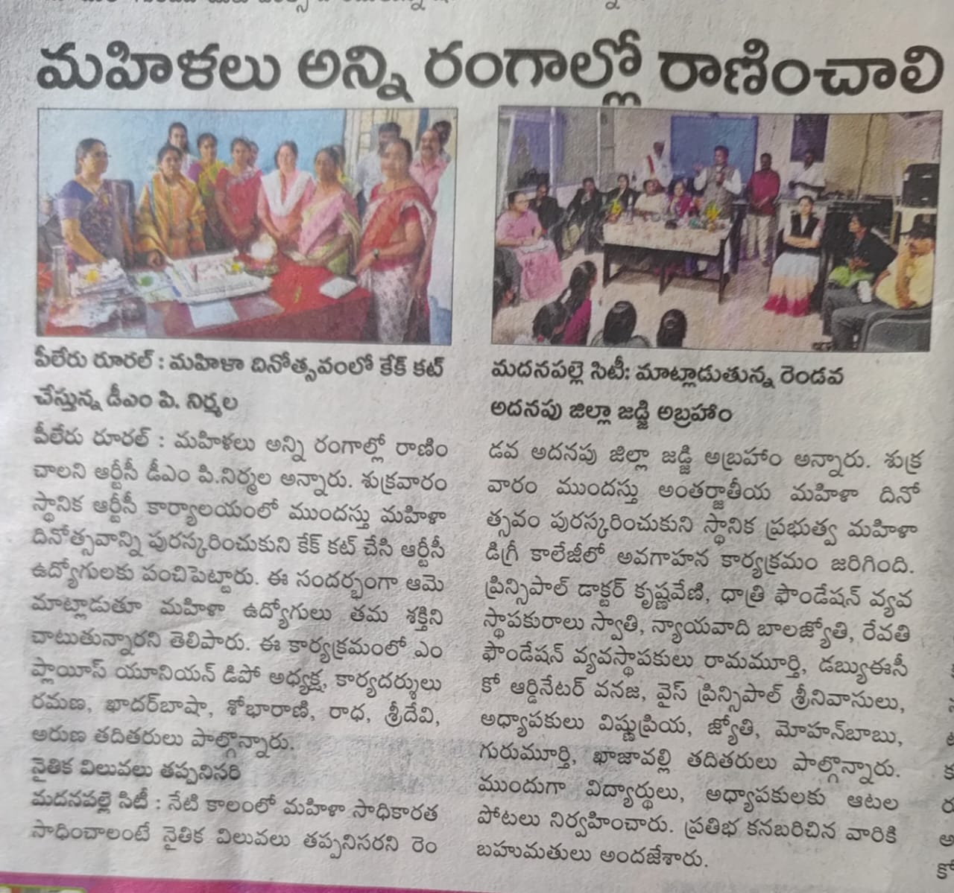

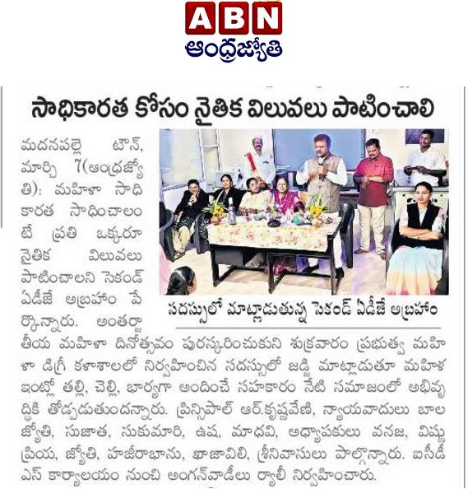

ABVP organized the volleyball and kabbadi tournament our students got volleyball winner and additional runners
The students of GDC(W) Madanapalle participated in volley ball and kabbadi tournaments organized by ABVP. The team stood as the winners in volley ball and additional runners in kabbadi tournaments. The Principal and the Physical Director congratulated the students.

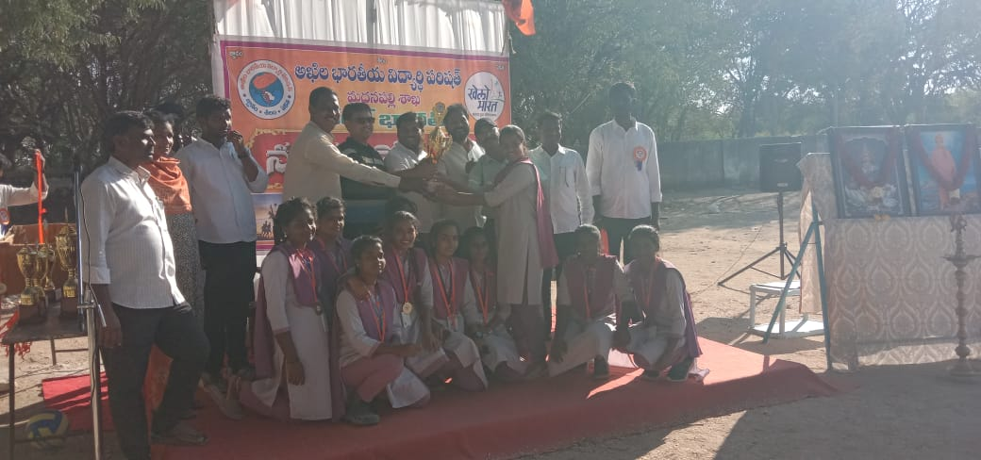
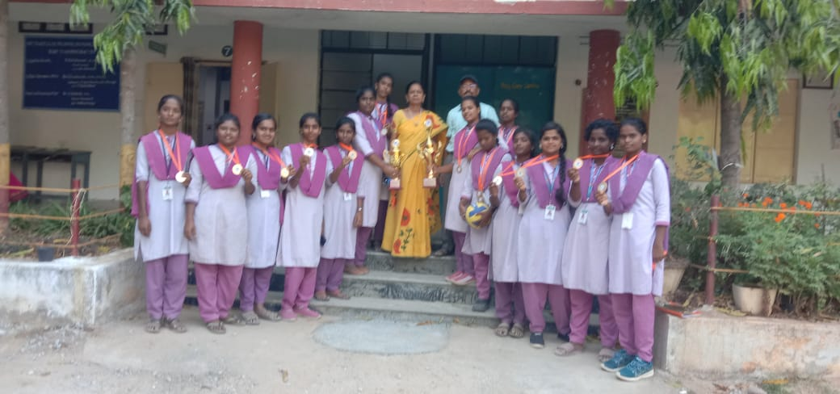
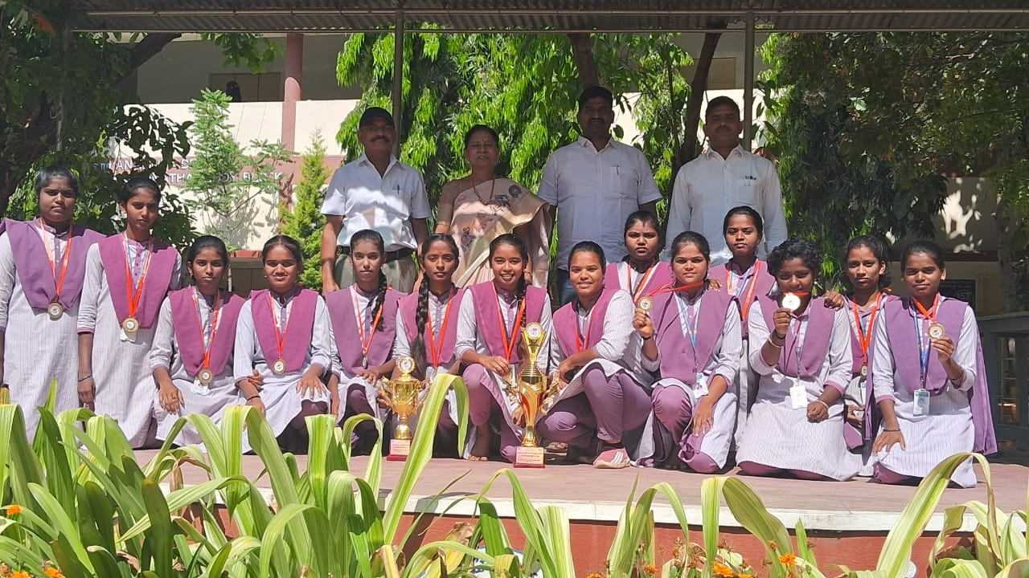
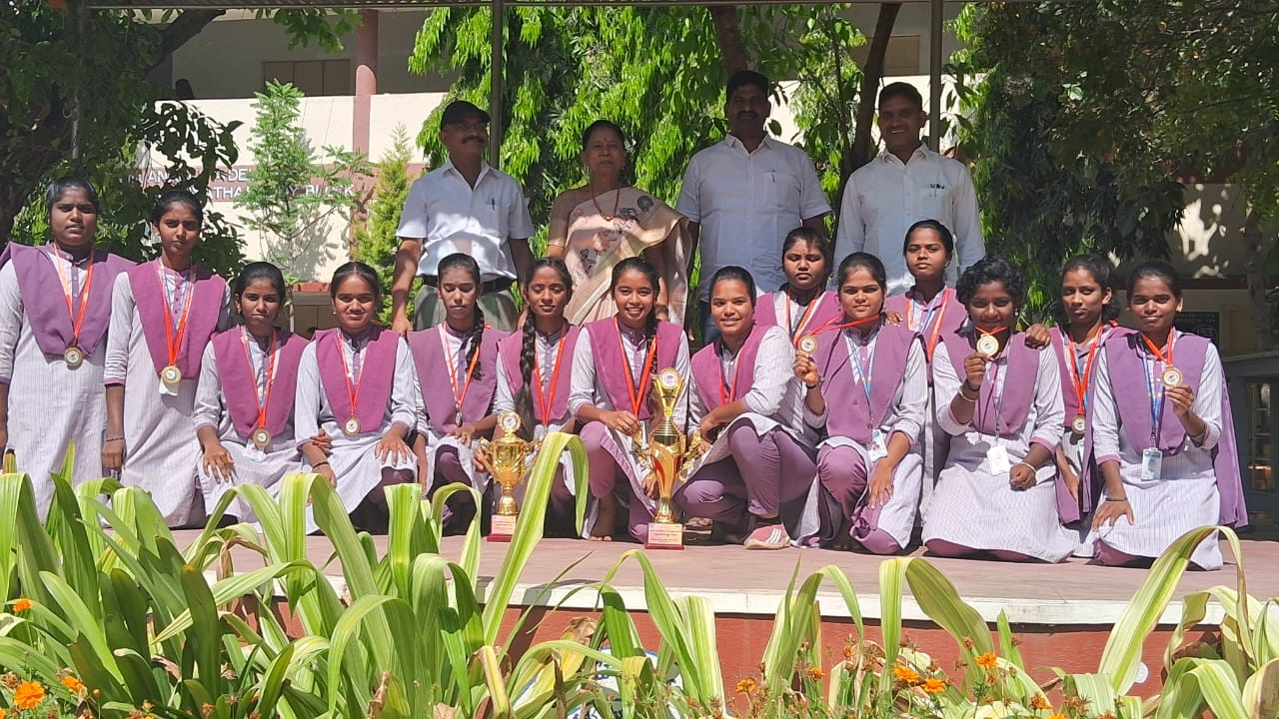

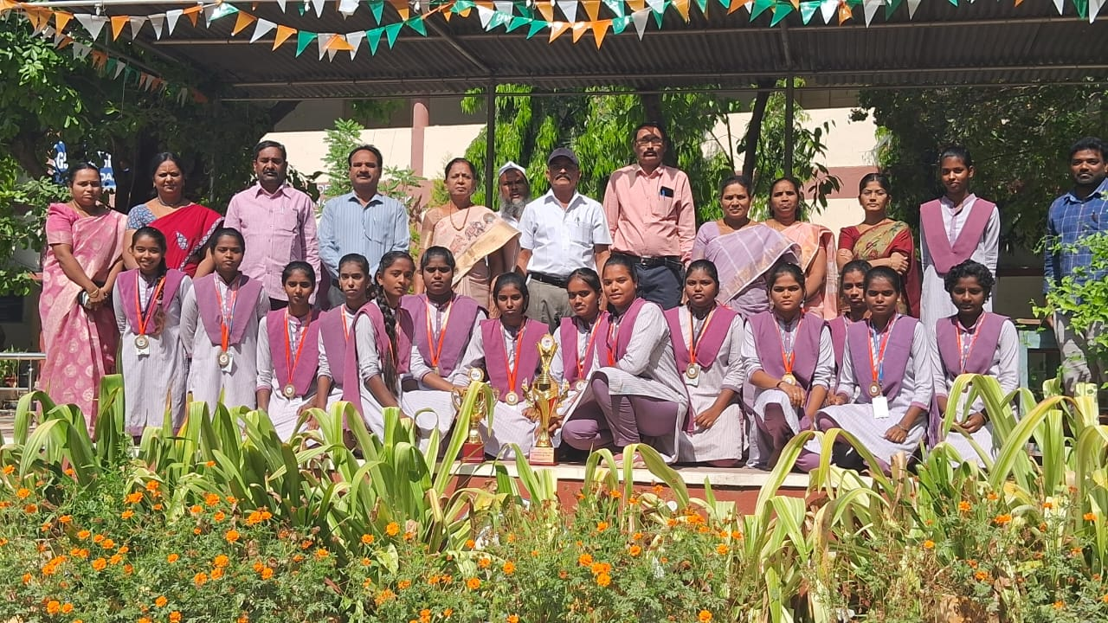

Academic audit 23-24, 24-25
As per the orders of The Commissionerate of Collegiate Education Academic audit for the years 2023-2024 and 2024-2025 was conducted in the college on 11/3/2025. The Academic Advisors ,Dr.G.Sreedevi and Dr Srinivasulu Reddy Thoroughly verified the records of the college as well as the departments and appreciated the efforts of the principal and the faculty.

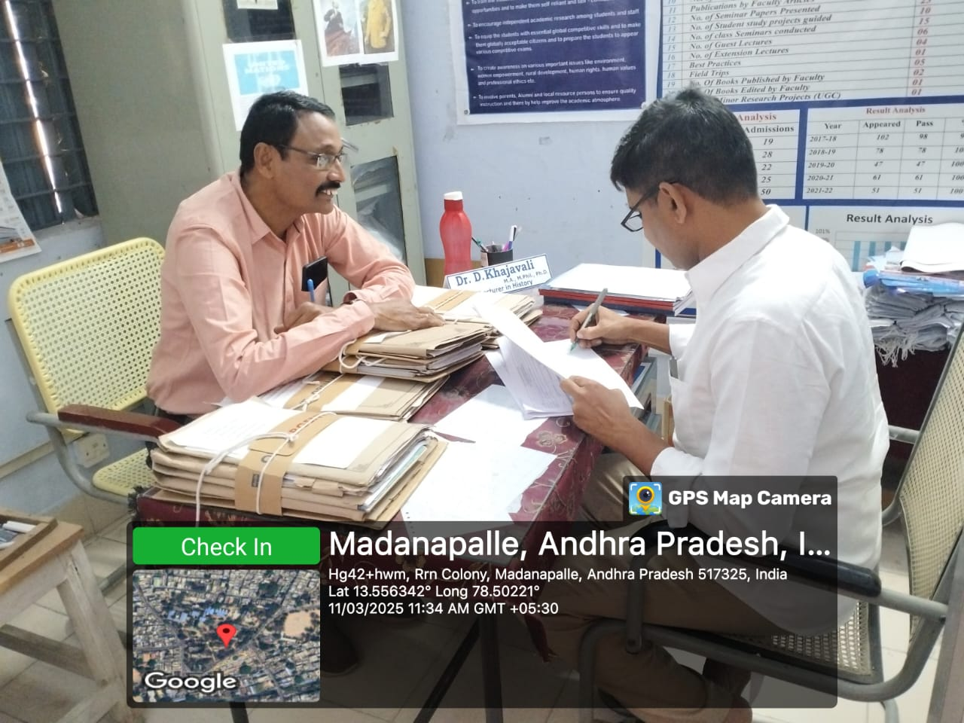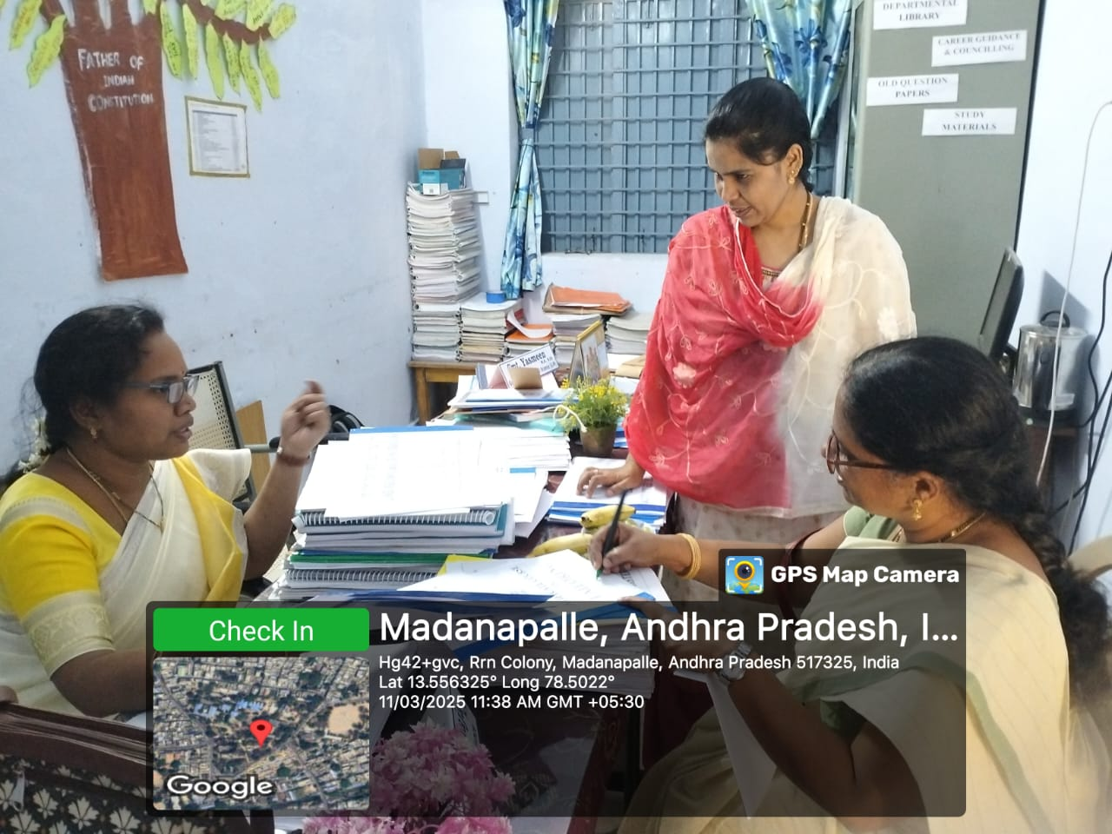
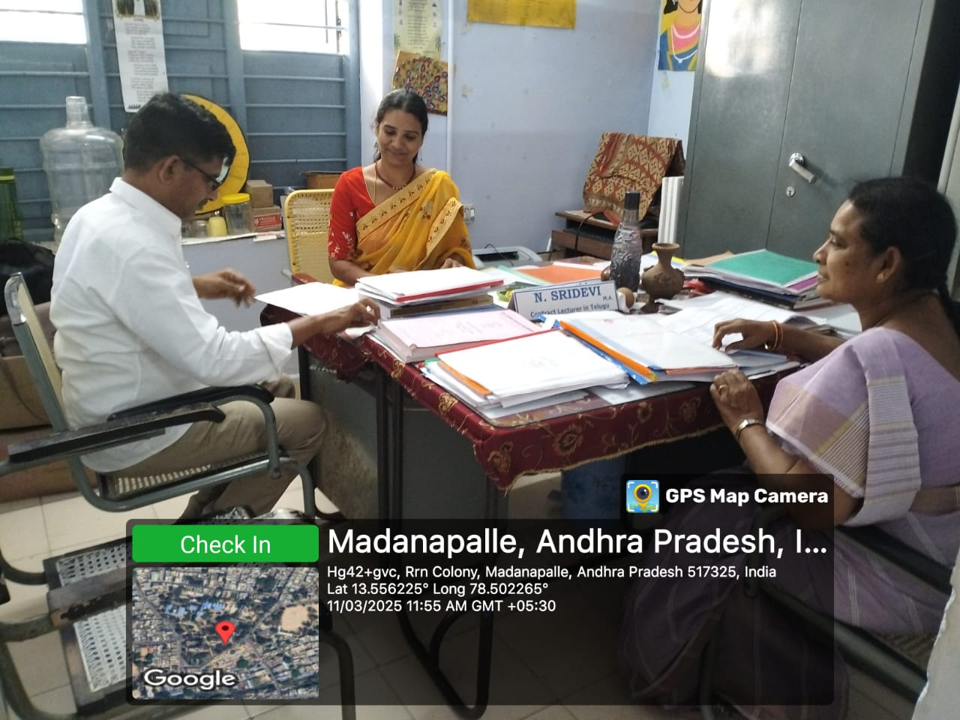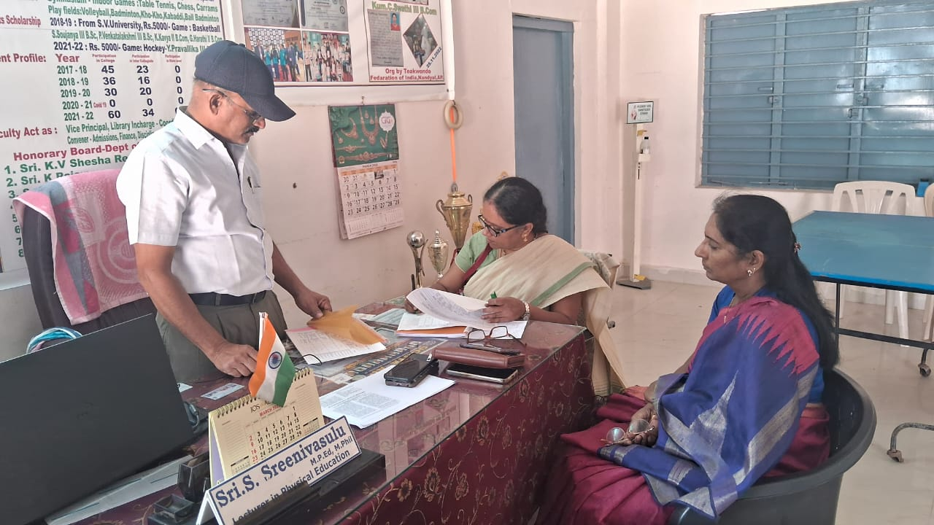

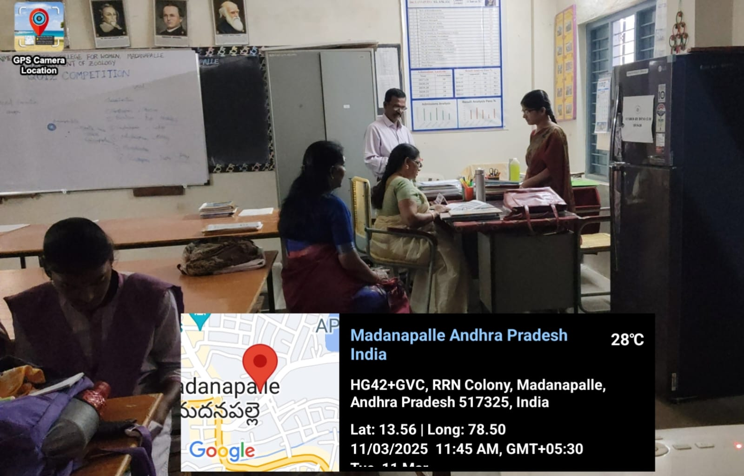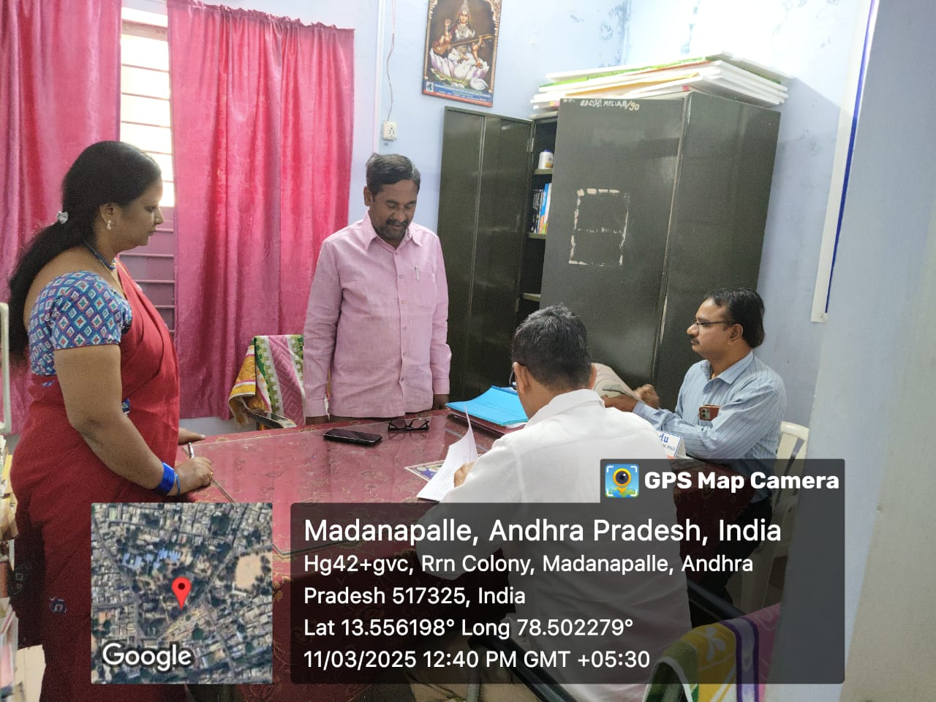
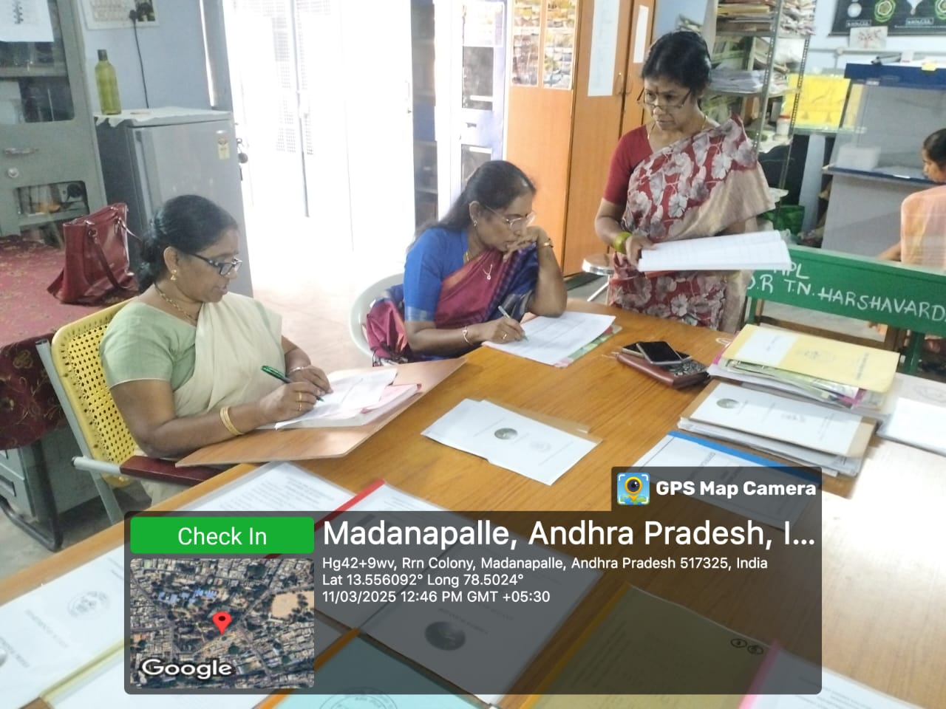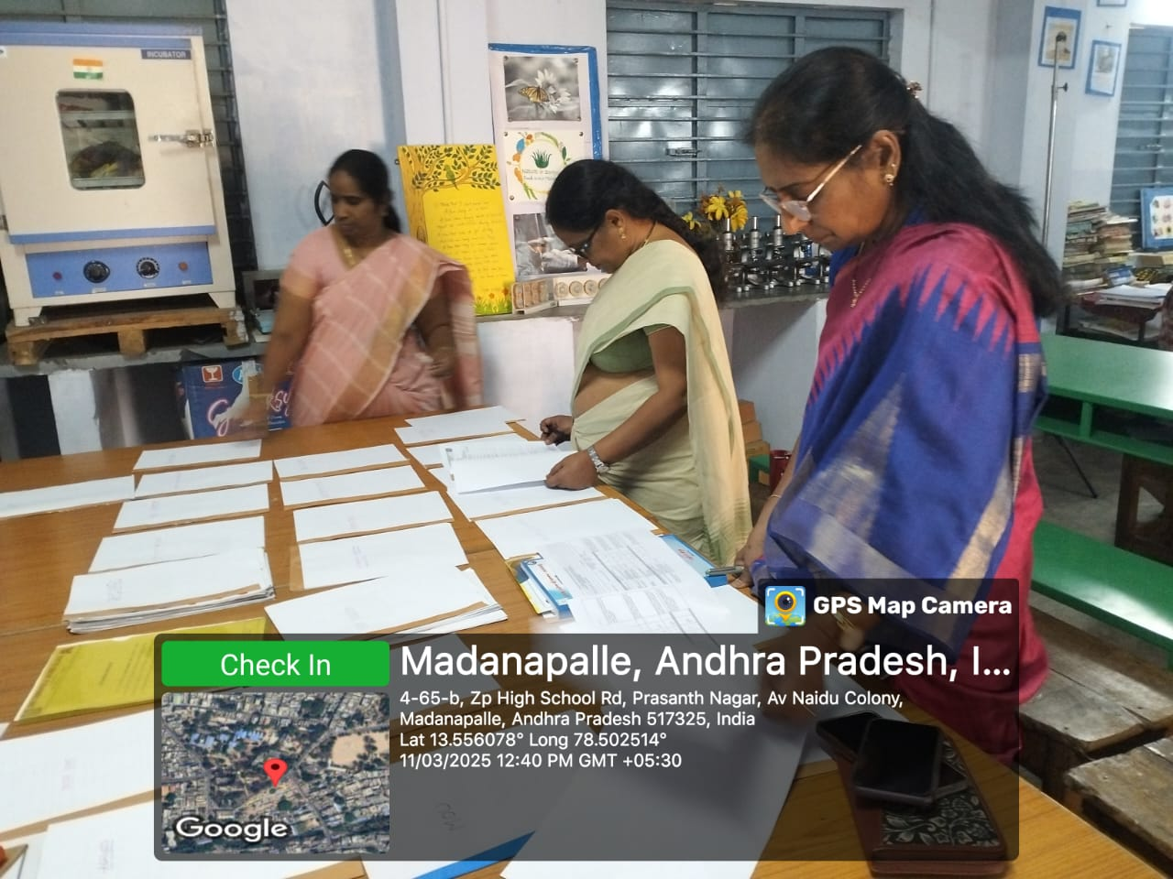

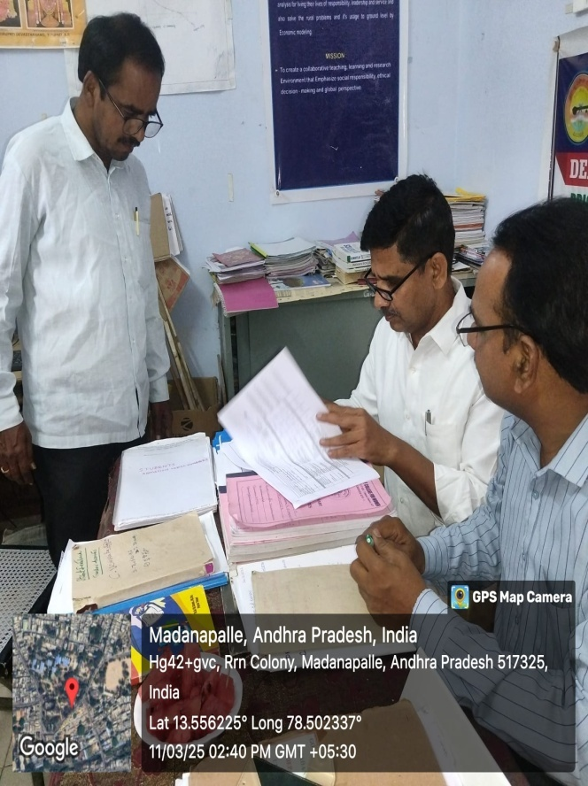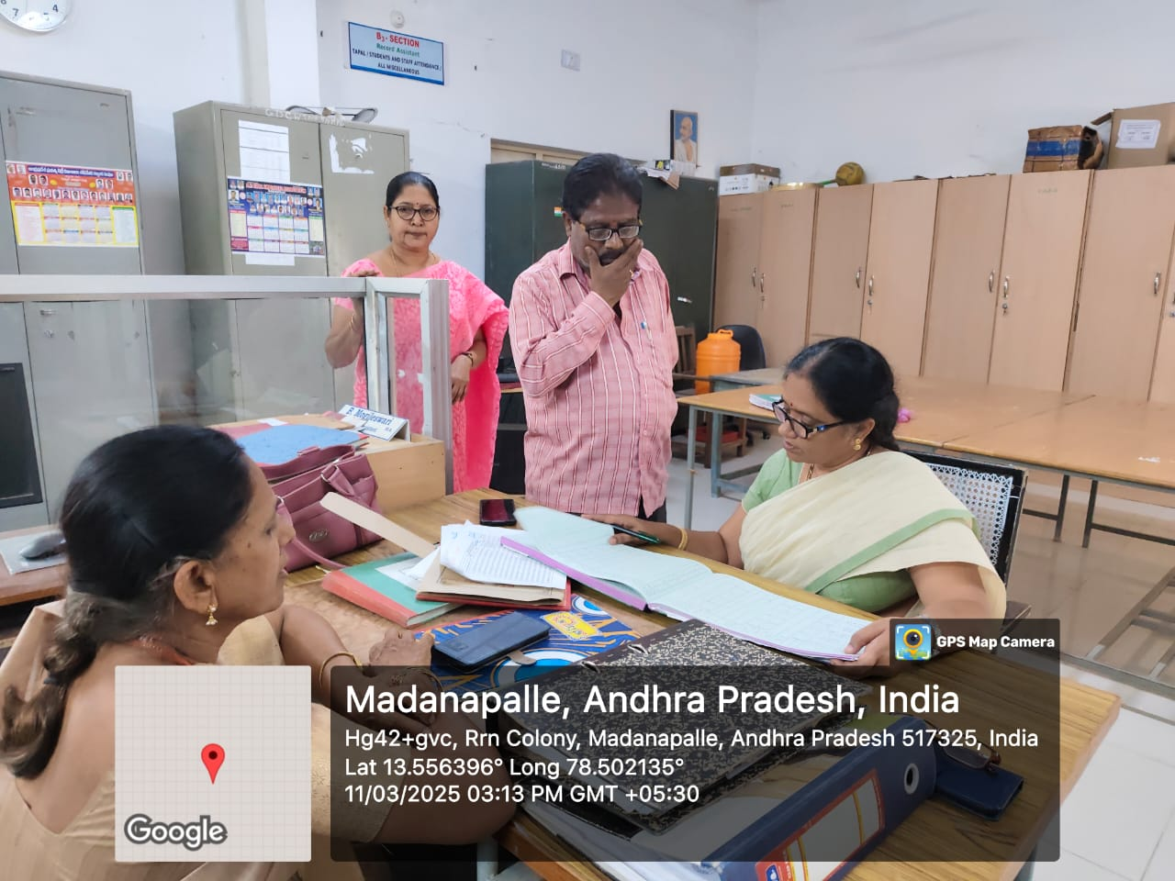
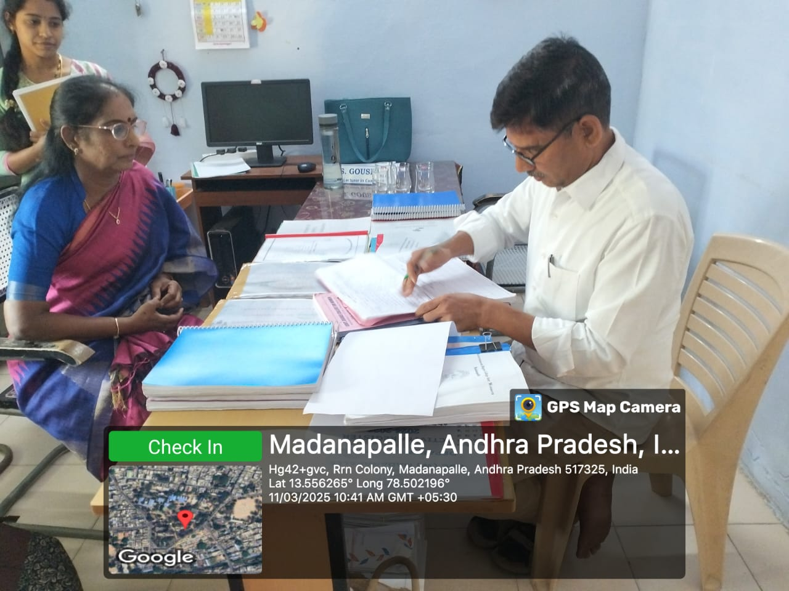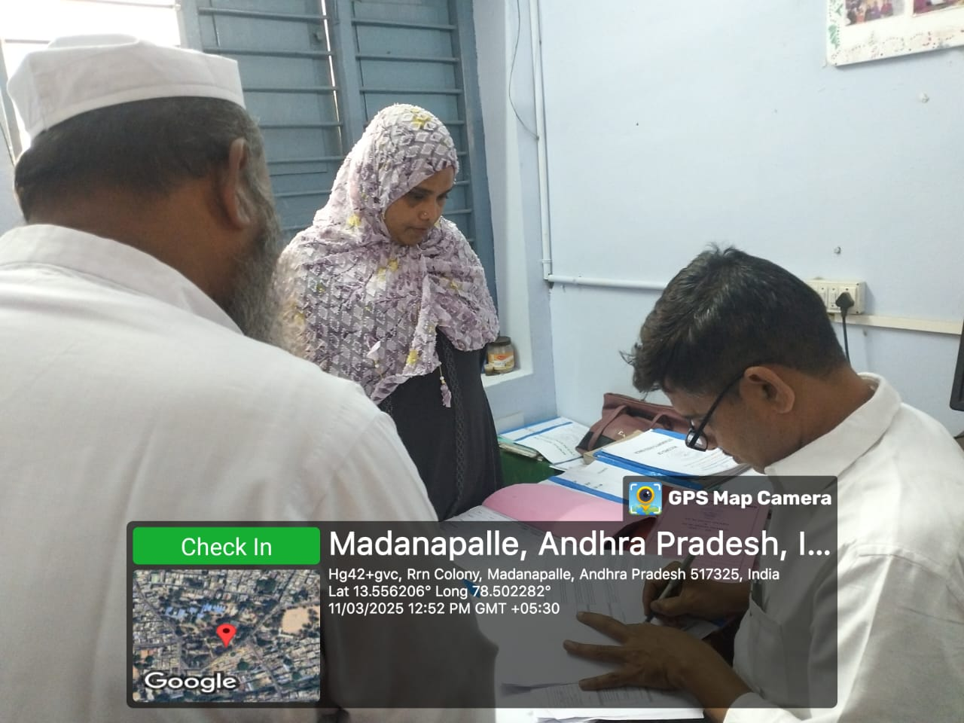
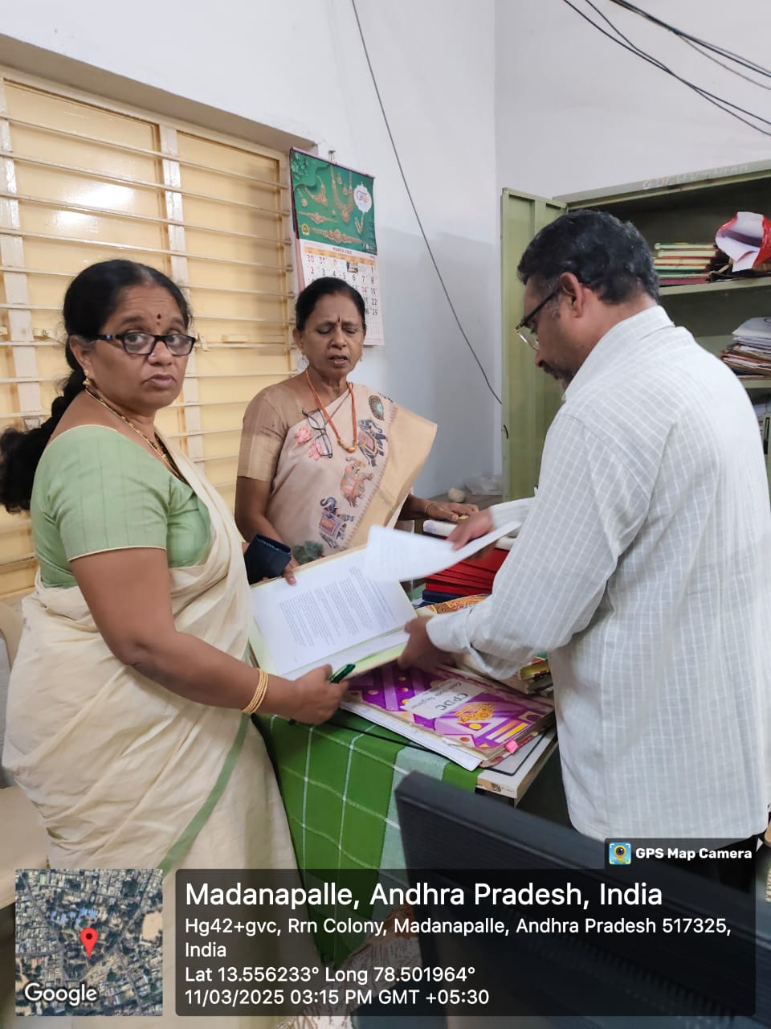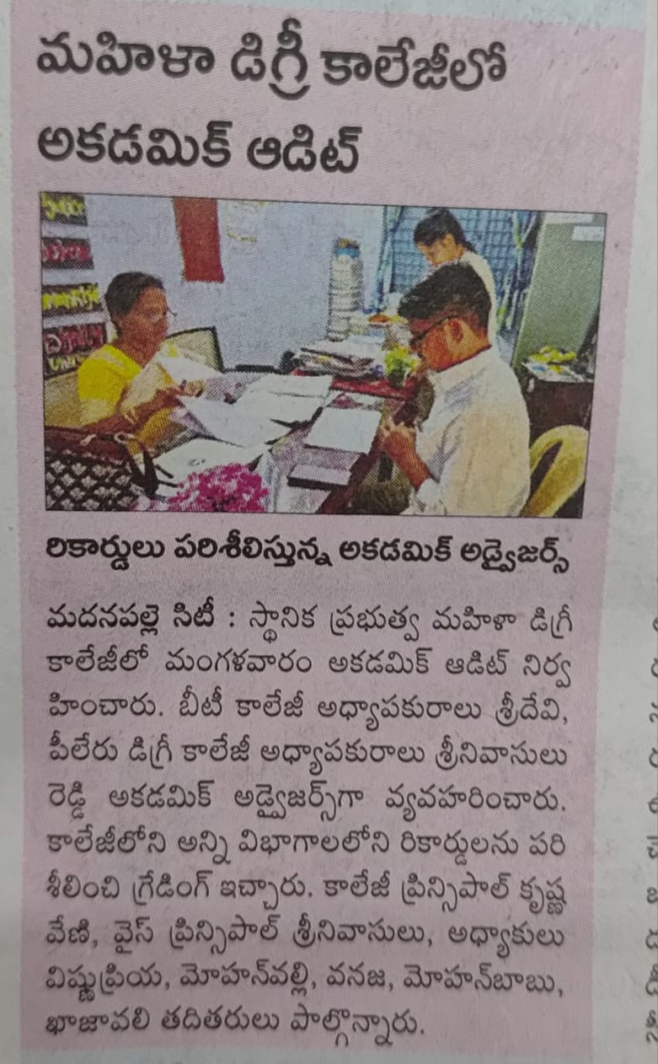

Poster Making Competition On The Dangers Of Plastic Usage
As a part of Swarna Andhra And Swaccha Andhra Program the department of political science conducted poster making competition on the dangers of plastic usage on 13/03/2025. The principal, the faculty and the students participated in it. A rally was also conducted to create awareness on the dangers of plastic usage.
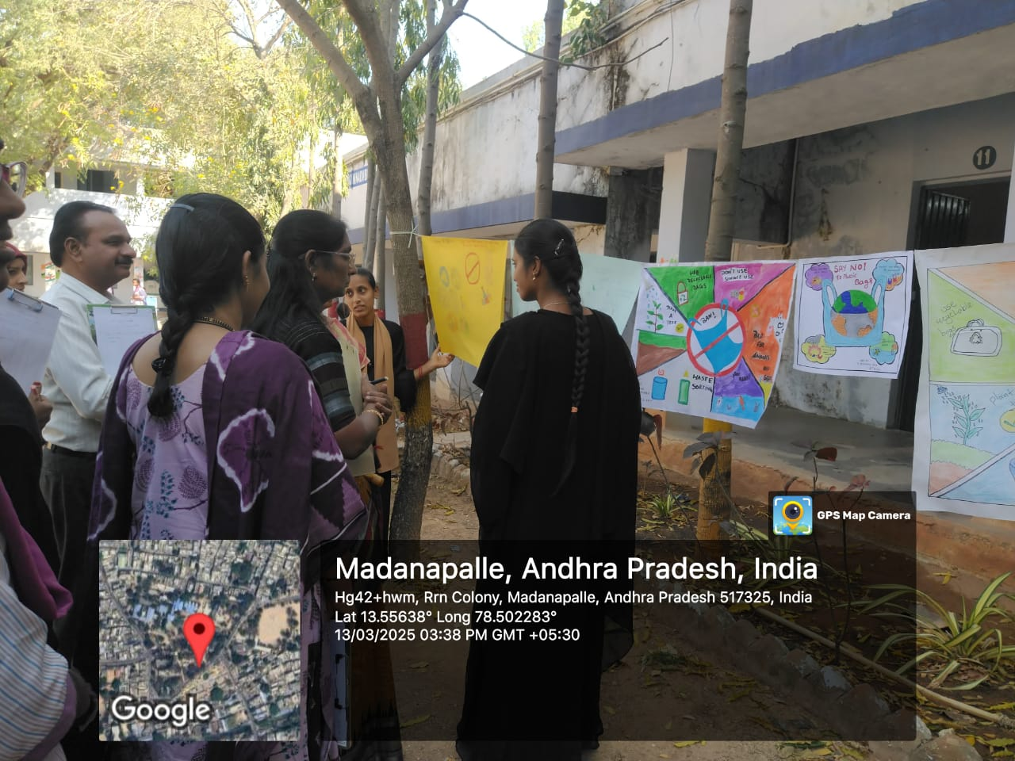

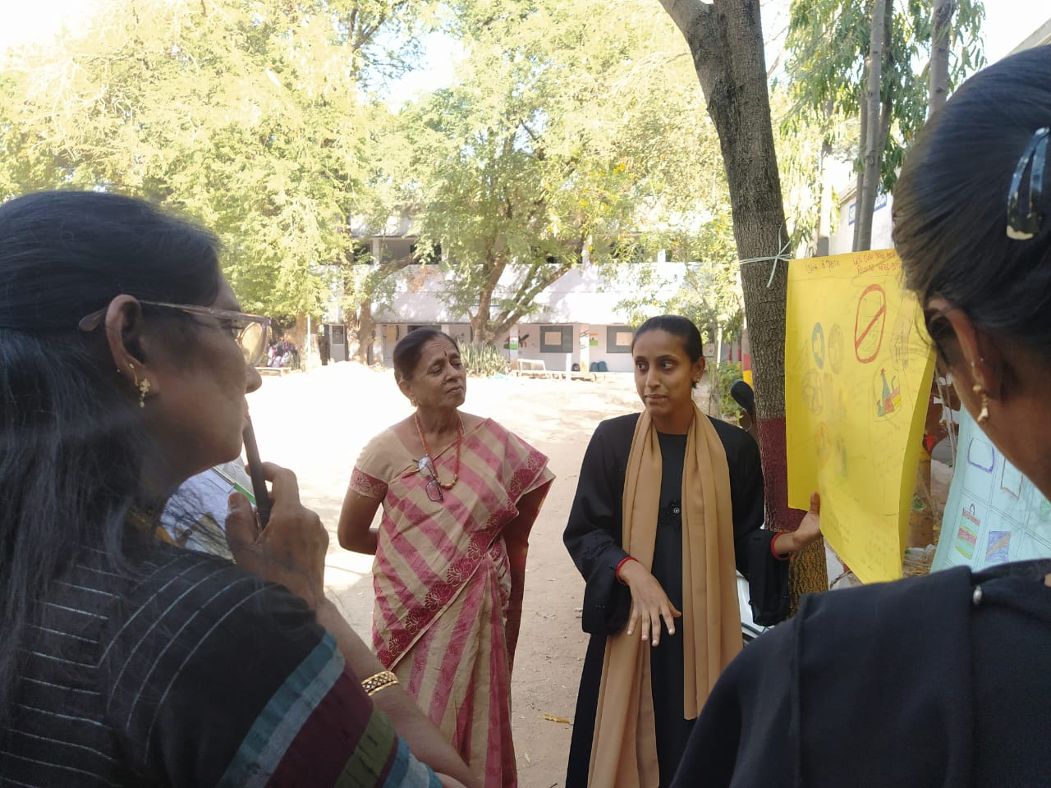

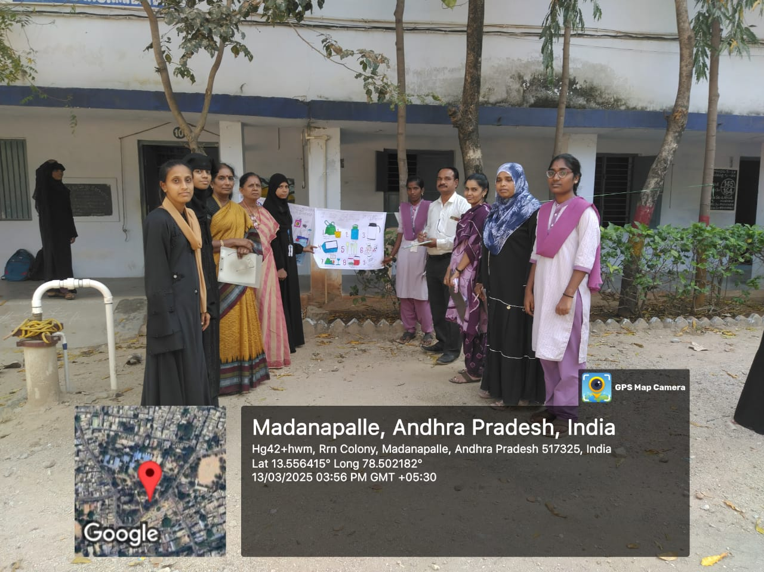
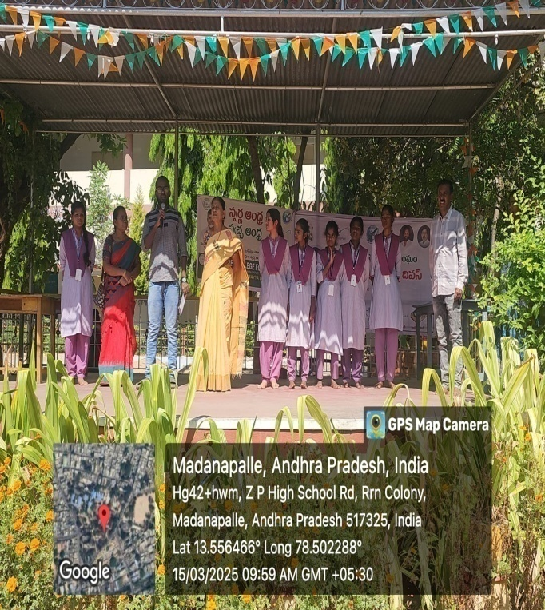

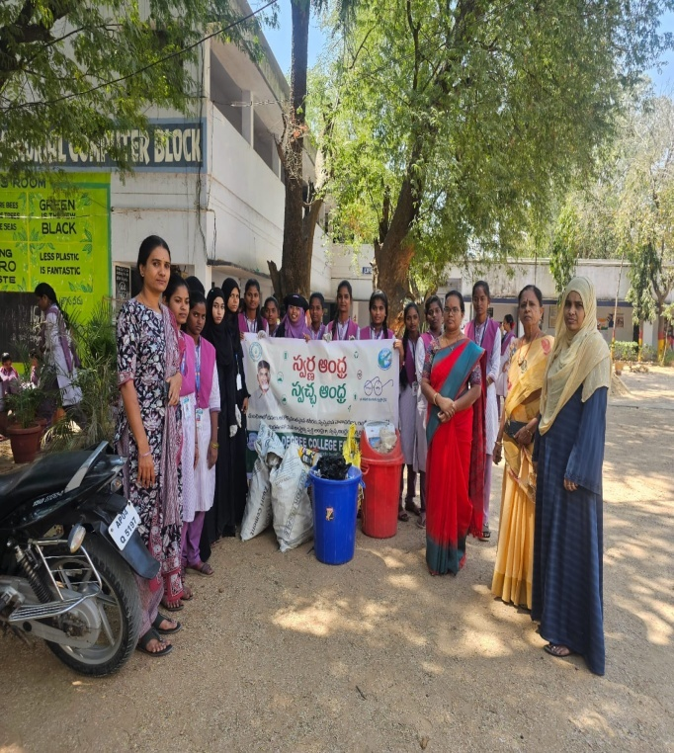
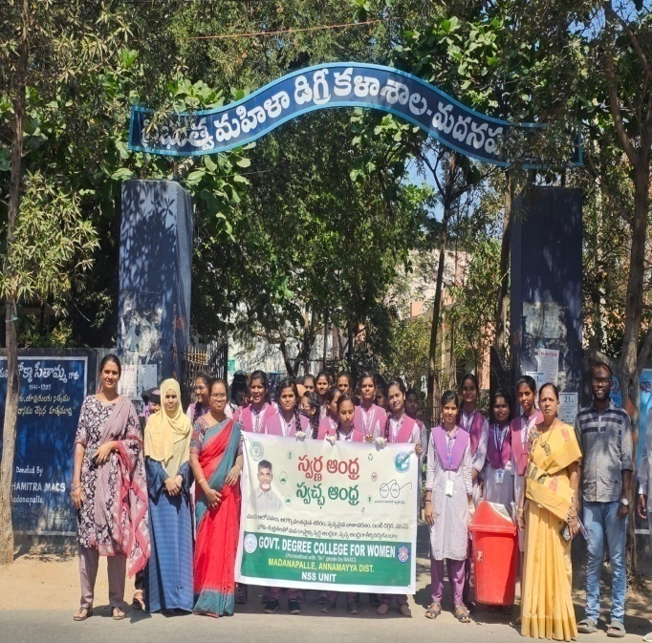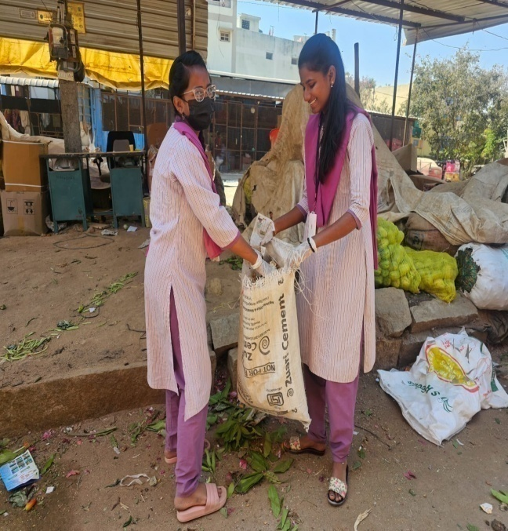

Essay writing competition organised by Department of Commerce as a part of World Consumer Rights Day celebrations
On the eve of World Consumer Rights Day an essay writing competition was conducted by the Department of Commerce on 15/3/2025.The principal and the staff participated in the program and distributed the prizes to the winners.

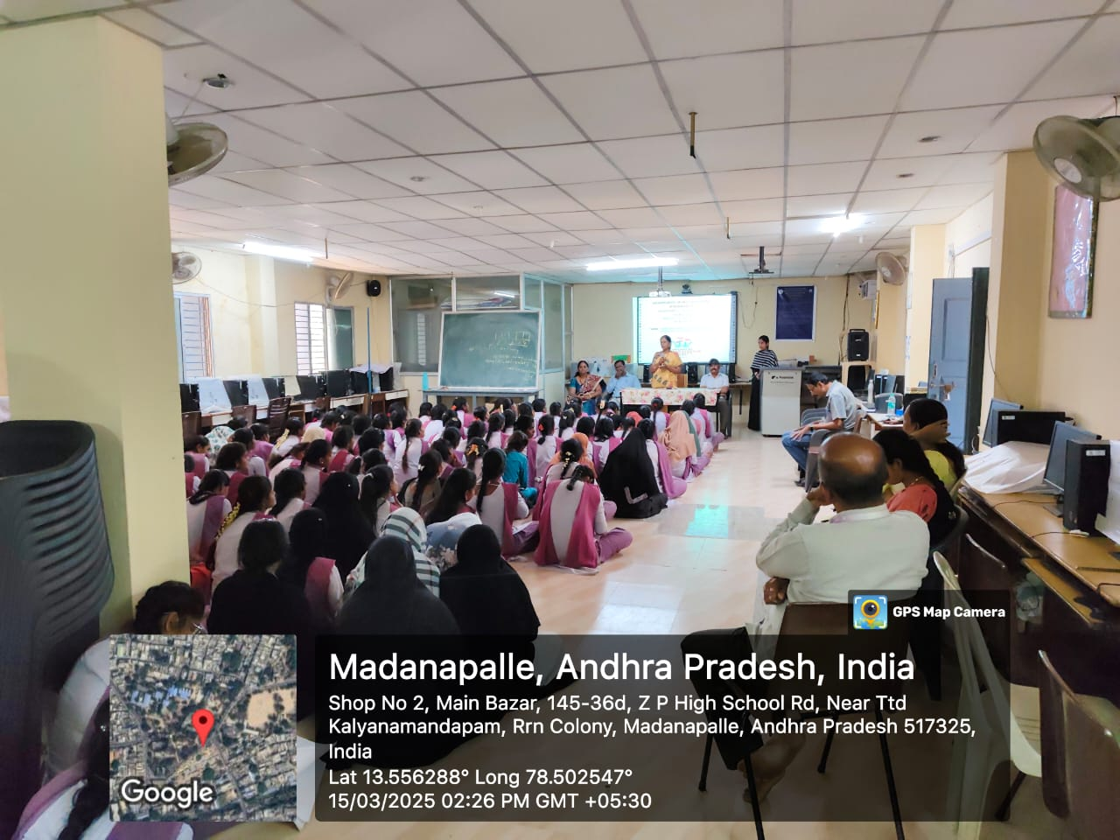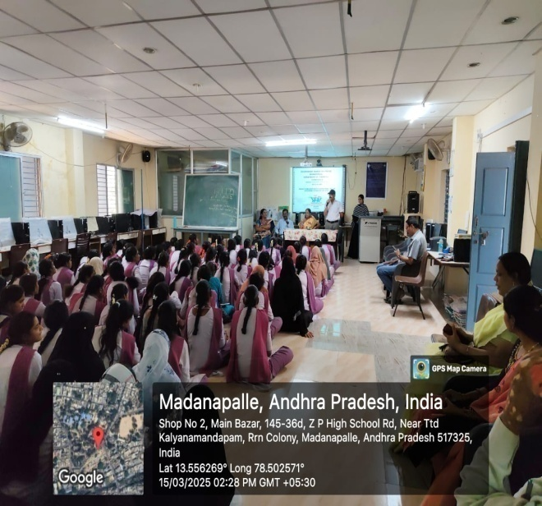

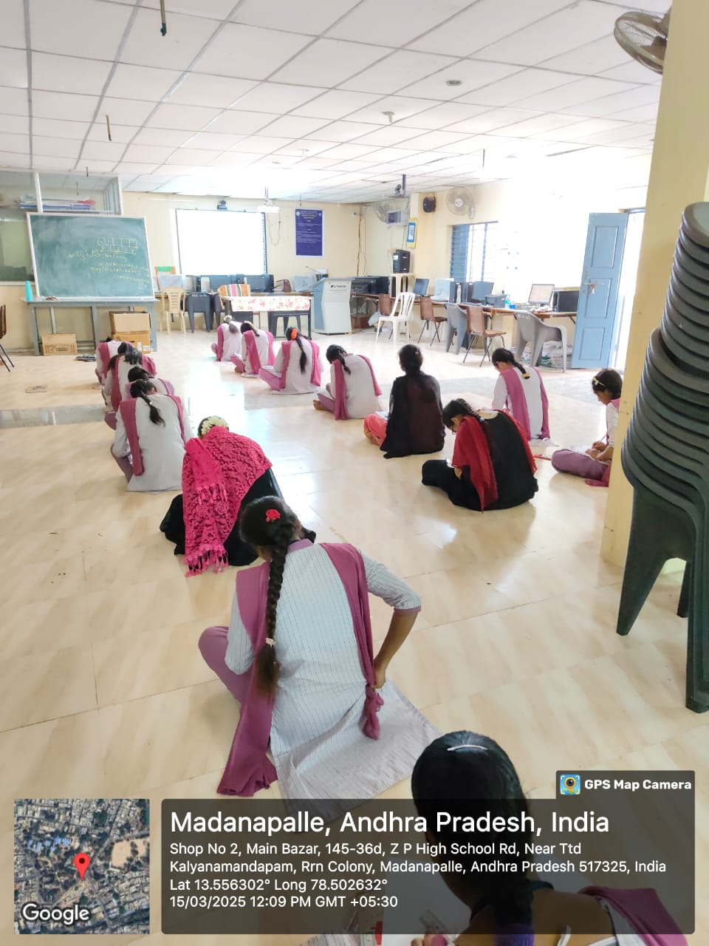

National youth Parliament competition at KSRM Engineering College, Kadapa.
The students of GDC(W) Madanapalle participated in the National Youth Parliament held at KSRM Engineering College, Kadapa on 21/03/2025 .

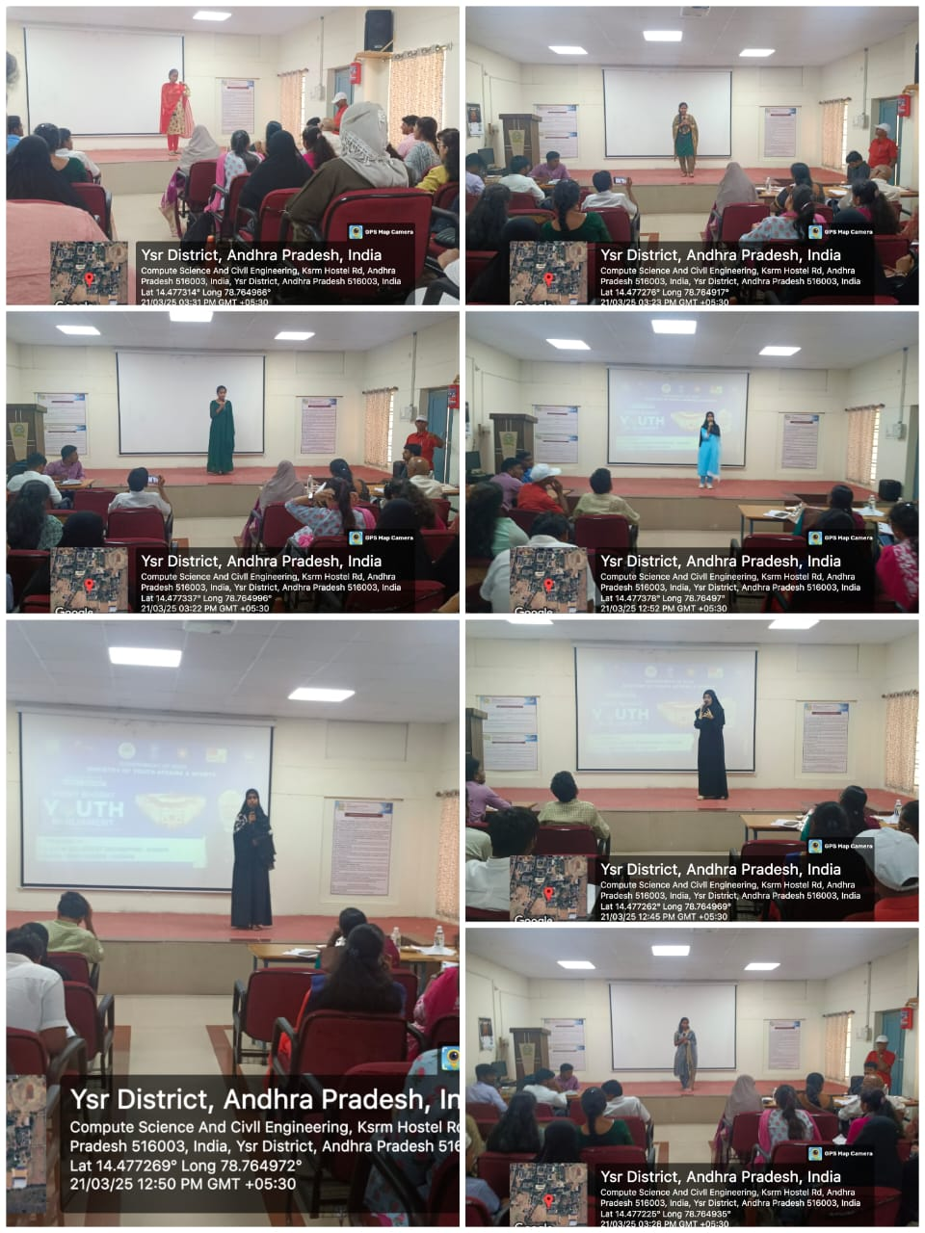
World Poetry day
The World Poetry Day was celebrated by the Department of English in the college on 21/03/2025 . The students participated and recited poems in the program . They also enacted for the poems written by the Nightingale of India, Sarojini Naidu .Prizes were distributed .The principal Dr.R.Krishnaveni, The English Faculty , Dr T.T.P. Mohan Babu and Smt J.Mohanavalli, The faculty of all the Departments and the students participated in it.
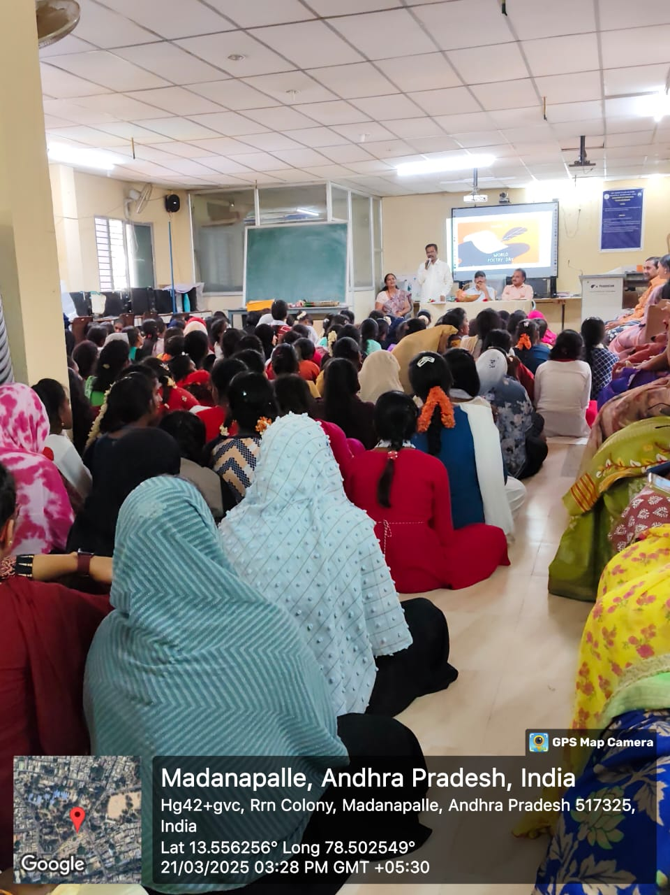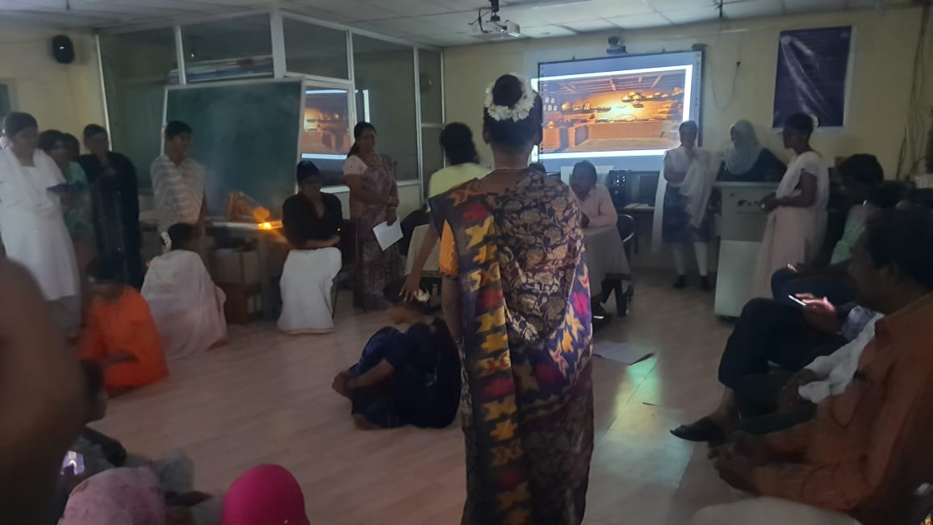

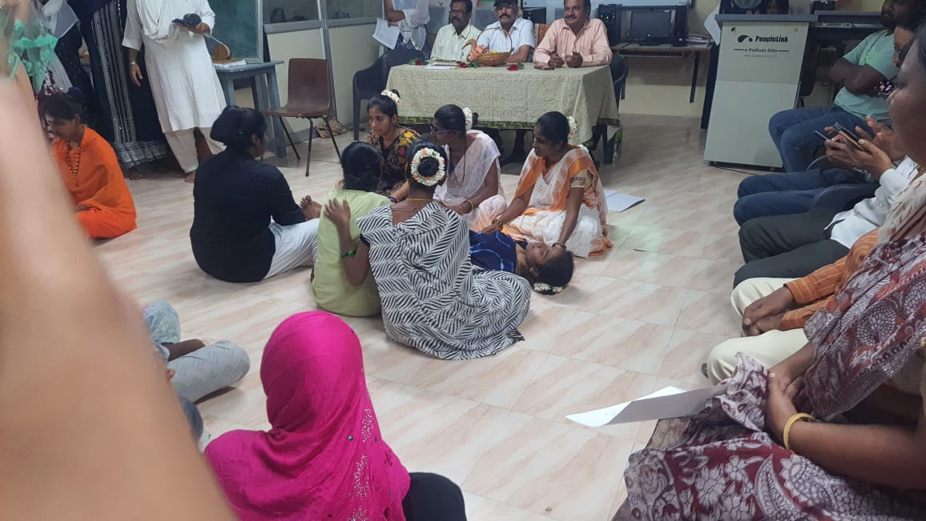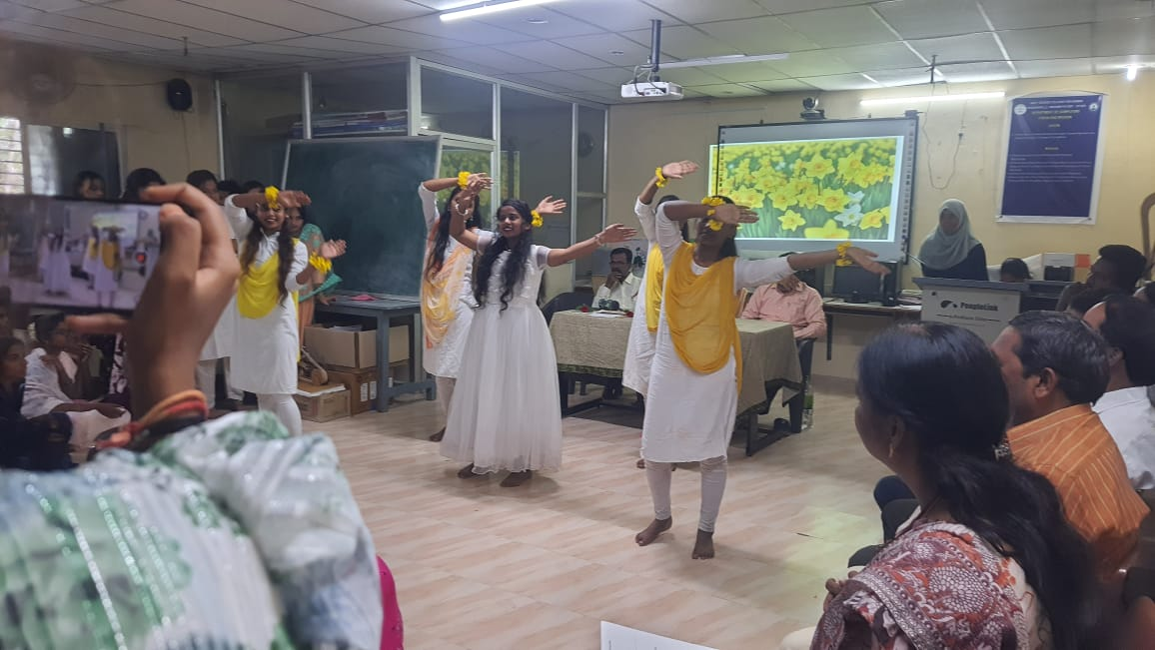

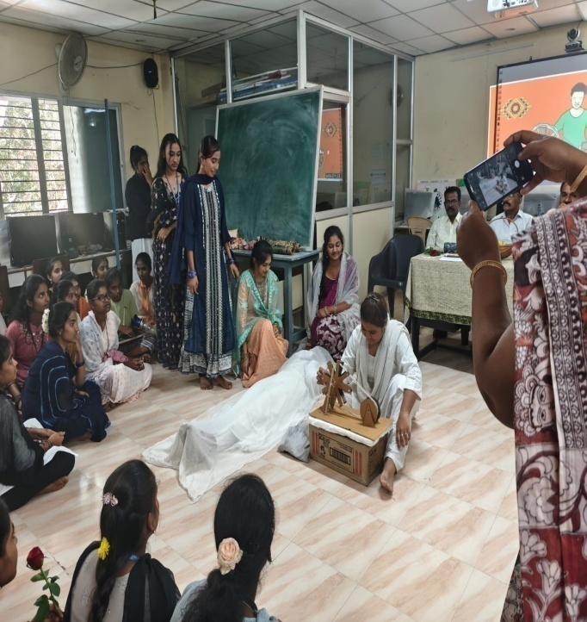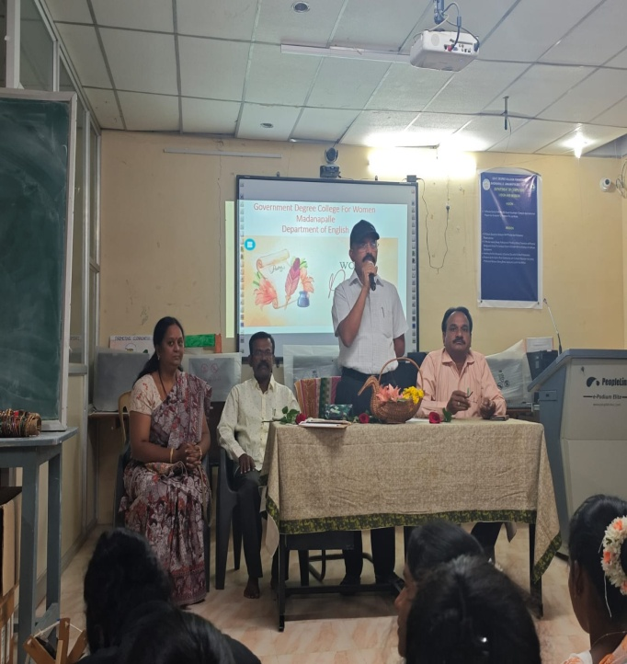

NFLP( Training Program)
The Principal Dr.R.Krishnaveni attended Nuturing Future Leadership Program held at MIED IIT, Roorkee from 22/03/2025 to 26/04/2025

/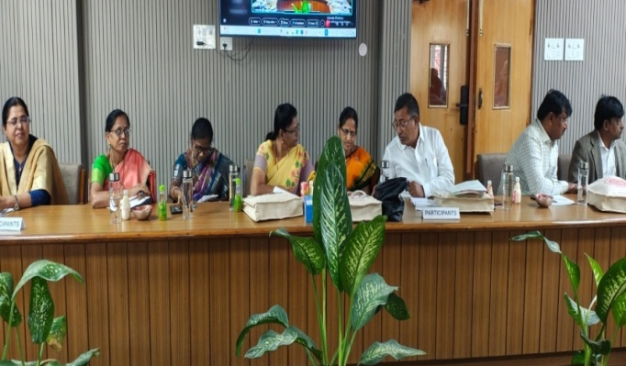 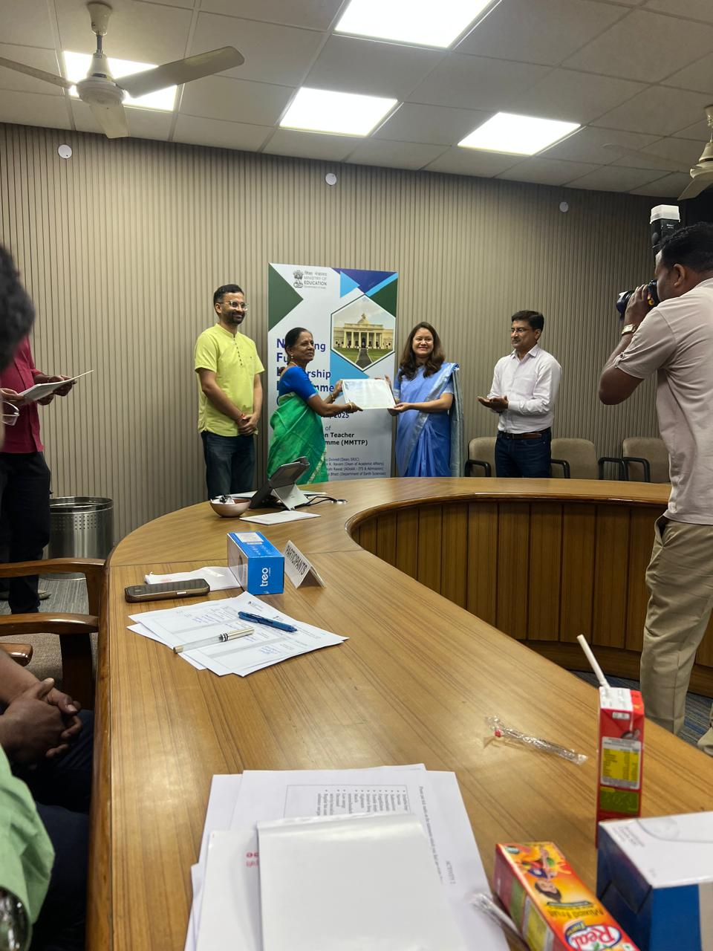
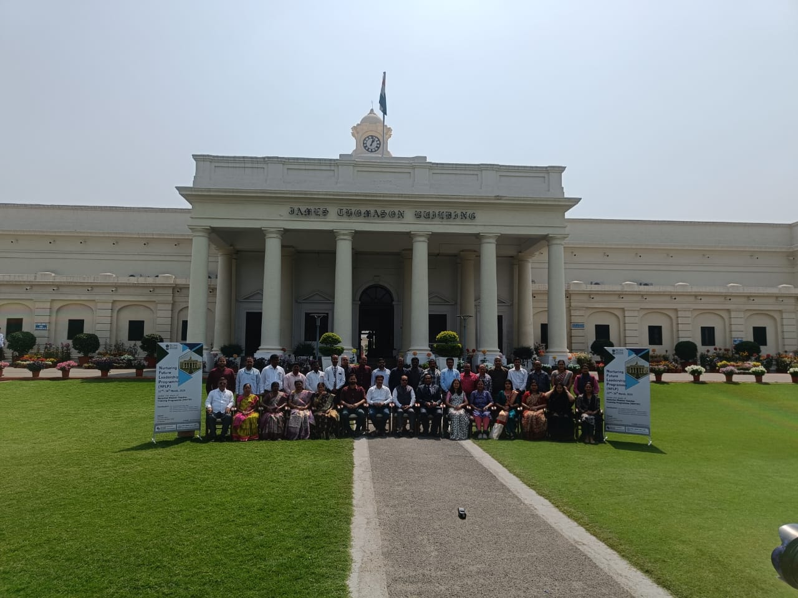

Distribution of Butter Milk by NSS.
The NSS volunteers of GDC(W) Madanapalle distributed buttermilk to the passers by before the college on 25/03/2025 . The NSS program officer Dr. B.Jyothi and the other members of the faculty participated in the program.

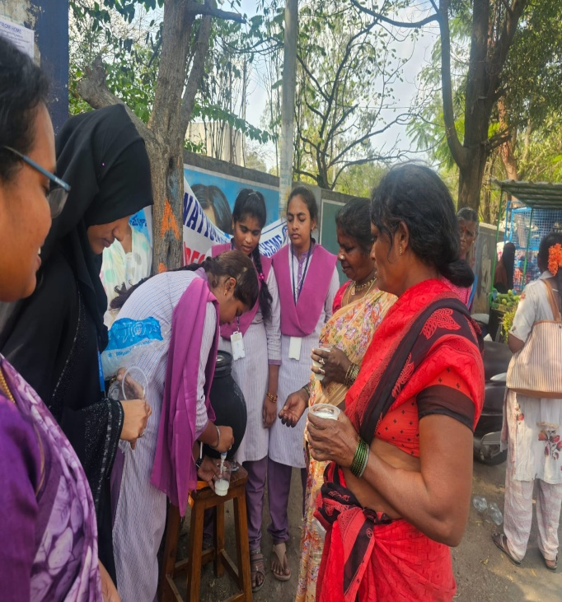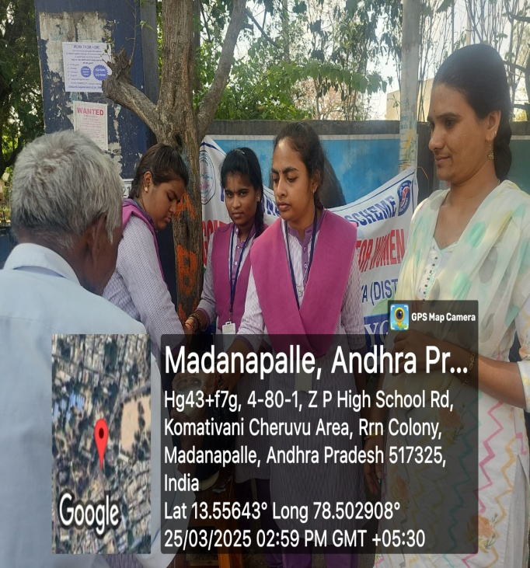
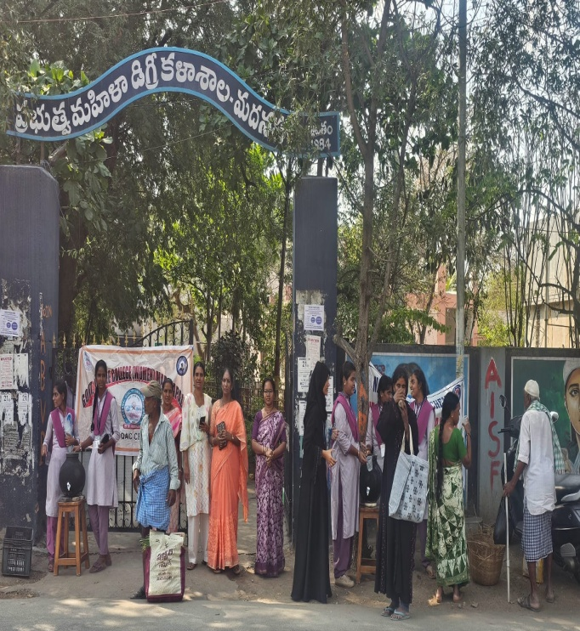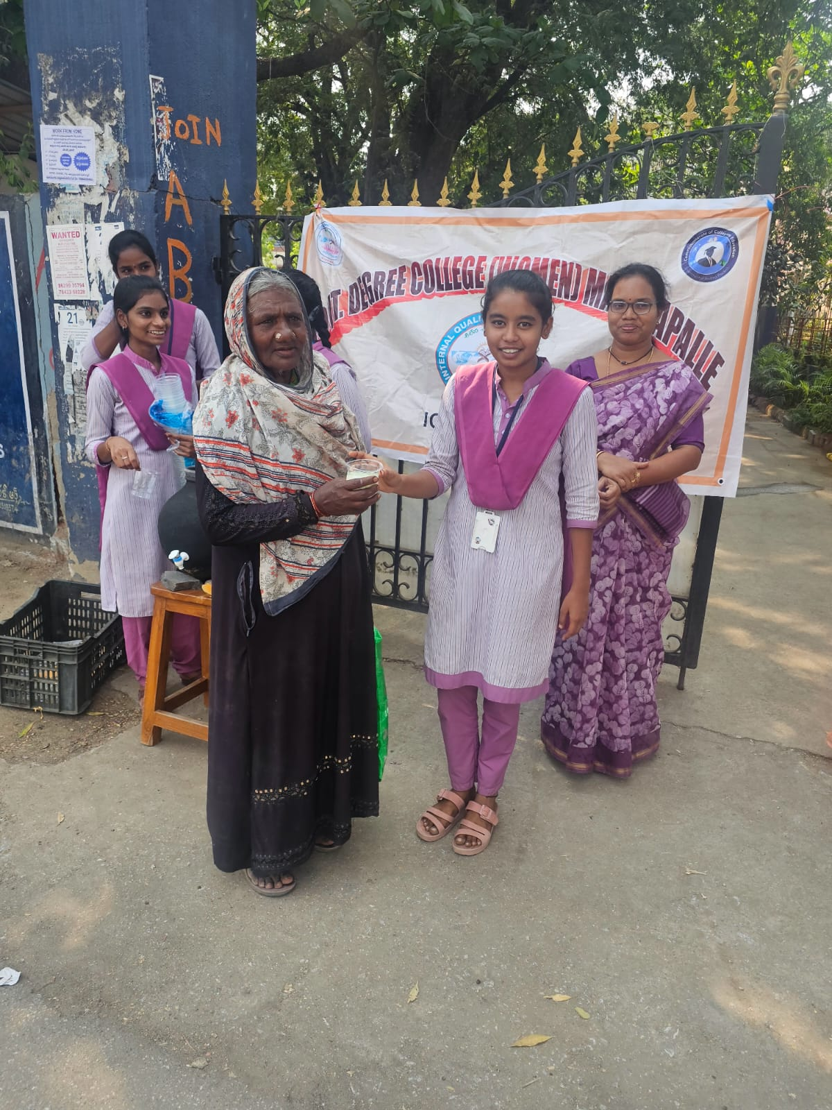

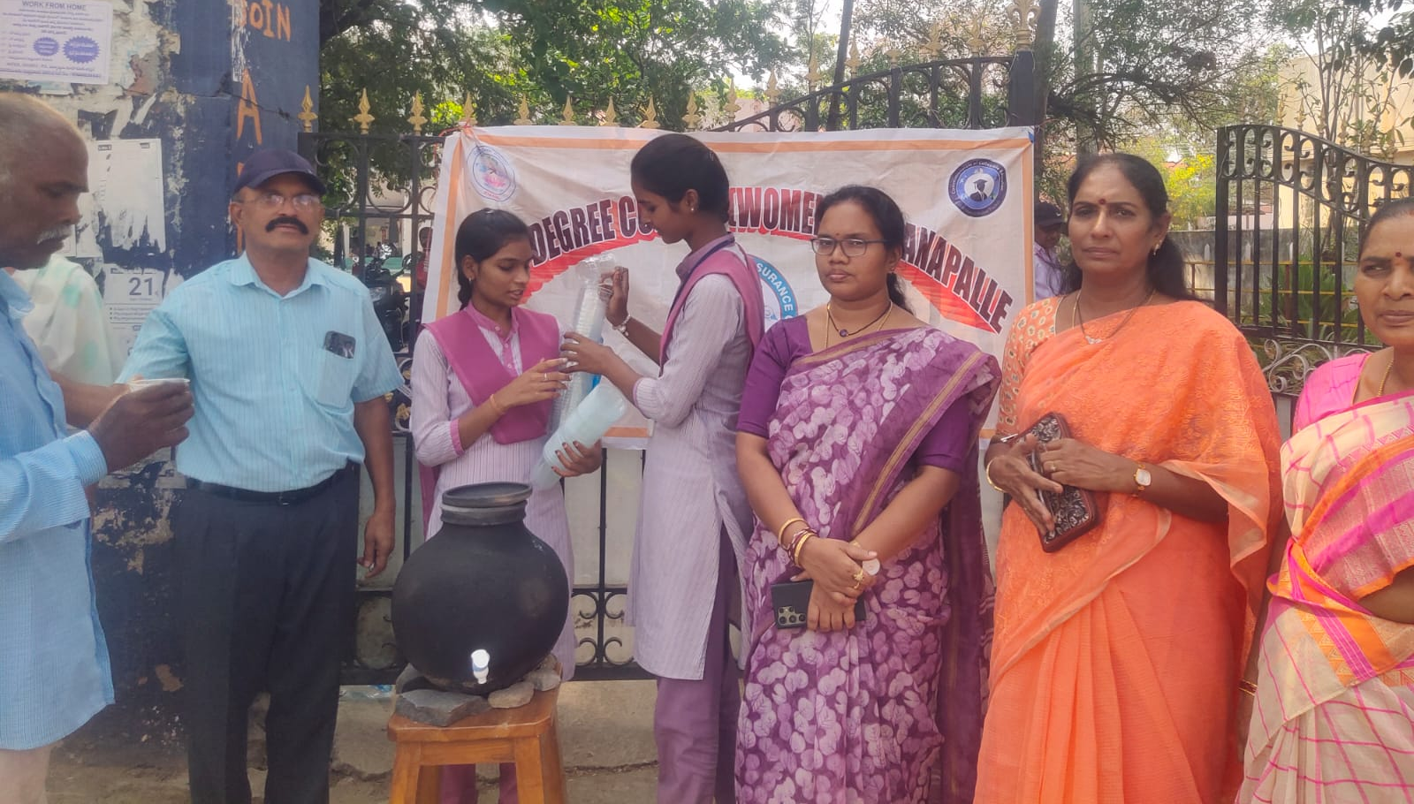

CAMPUS JOB DRIVE
On 29/03/2025 Campus recruitment drive was hosted by Jawahar Knowledge Center of GDC(W) Madanapalle at our college. Nearly 7 different companies /HR agencies participated in it 123 students were selected for the posts of data entry operators/sales executives/executives for the A.C and Mobile phone manufacturing units .The vice Principal Sri S.Sreenivasulu , The JKC coordinator, Dr.T.T.P.Mohan Babu helped the students and the companies in the process of selection.

